**Chapter 4 – Design and Development Phase**

The Design stage of a project is a phase in which the design of the Graphical User Interface (GUI) for a smooth User Experience (UX) of the application is conceived, as well as the design of an appropriate Data Storage for the application. During this phase, using a storyboarding process, Screen wireframes are created as Blueprints to allow developers to build the application.

The wireframes are an UX-based view of how the application is going to work and show the logic and flow of the application operations. It is also taken into consideration the attractiveness of the app, meaning it is important to mix the design in terms as aesthetics to the functionality of the application. In a real word situation, this phase is made according with the client, so all aspects are in accordance before they move on to the next phase which is the development.

After all the wireframes have been provided, the app can actually be built, this is called the Development phase of a project. With the Rapid Application Development methodology, as being used in this project, the coding process is done with prototype versions being created, which breaks the development up into iteration versions of the prototype, and each iteration is focused on a different bit of functionality. Once all these versions are complete, the project goes to the UAT (User Acceptance Testing) version, which the client can test and sign off. By the end of this phase, the client should have the product developed with all the specification integrated and the whole source code for the application.

The current project is also based on Voice User Interface (VUI), which involves the communication with a *Smart Home* device (IoT device), in this case - *Google Home*. The user is able to perform a search for desired pet through a voice control of Google *Assistant* from the *Google Home* device, and by doing so, the result of the search will appear on the app without the need of clicking through its buttons. The platform used to develop the VUI is the *Dialog Flow*, which will be described at the end of this chapter.

The proposed mobile app starts with a *Splash* screen, emphasizing the *logo* of the project. The *splash* screen, or *start* screen, or *start up* screen, is defined by Techopedia (2016) as a specific screen to be displayed while the application is still loading. Once it is loaded, the user will be directed to the main application screen (*Home* Screen).

**4.1 Screen 1: *Home* Screen**

When the user opens-up the application, the first screen they see is the *Home* Screen, which has two clickable links: the first one is intended for a user that has already been registered within the *Pawdopter* application (the potential adopter has already created a user profile and recorded in the app’s database). The second button, is for users who are not yet registered within the application, meaning that they need to Register first, before been properly Logged in (Signed in) the application to use its functionalities. The Wireframe of this screen is presented on Figure 4.1a.

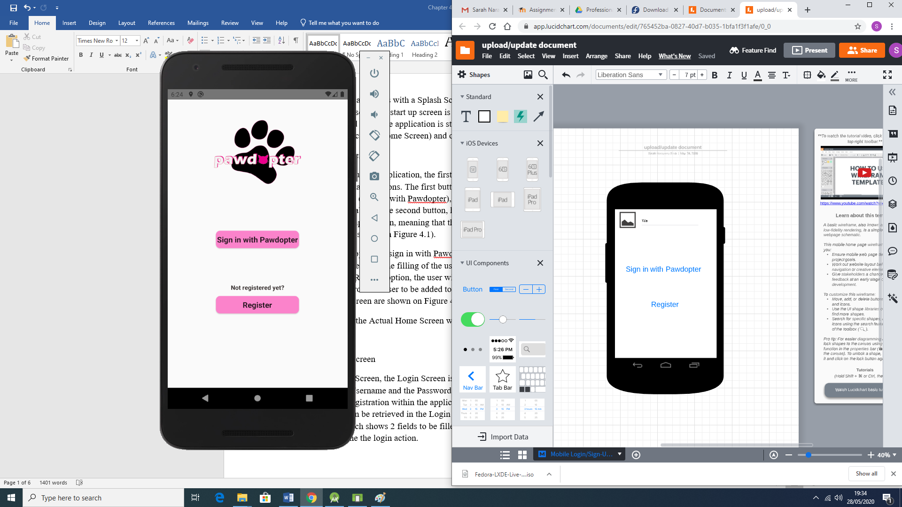

Figure 4.1a: Wireframe for Application Screen 1: Home

Clicking on the option to *Sign in with Pawdopter*, the potential adopter is redirected to a *Login* Screen, which requires typing of username and password, as provided at registration point. Clicking on the *Register* option, the user will be redirected to a *Registration* Screen, which will collect necessary data from the user to create a *user record* in the database. Figure 4.1b shows snippets of code (Java code to the left, and XML code to the right) for the *Home* Screen, while the actual application *Home* Screen is displayed on Figure 4.1c.

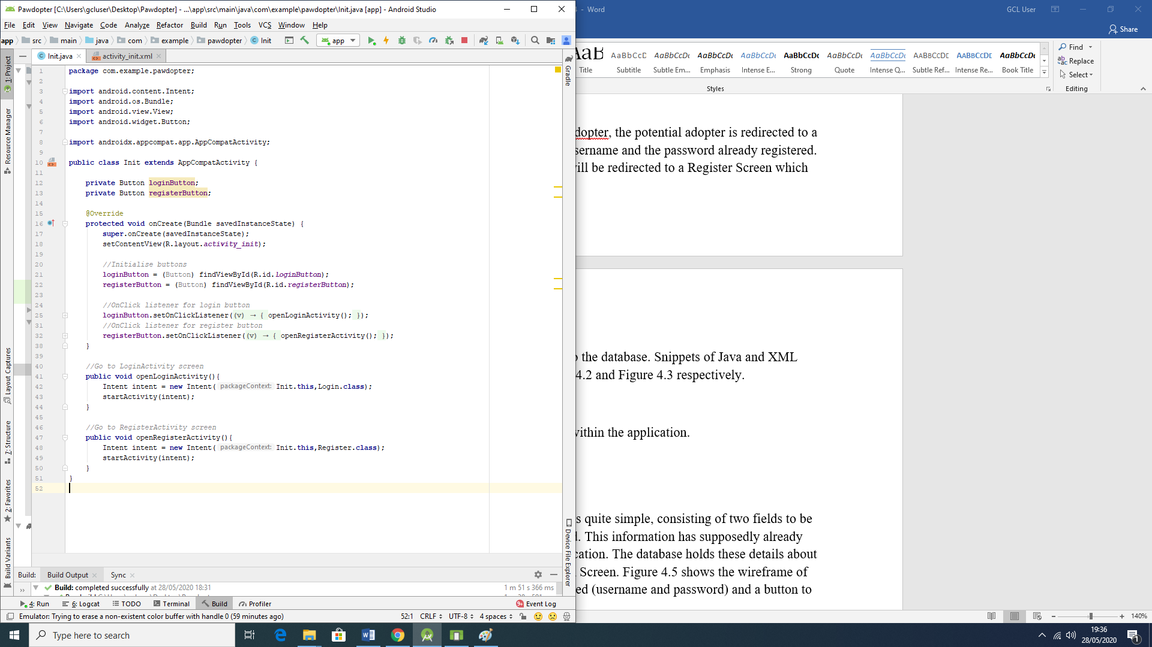 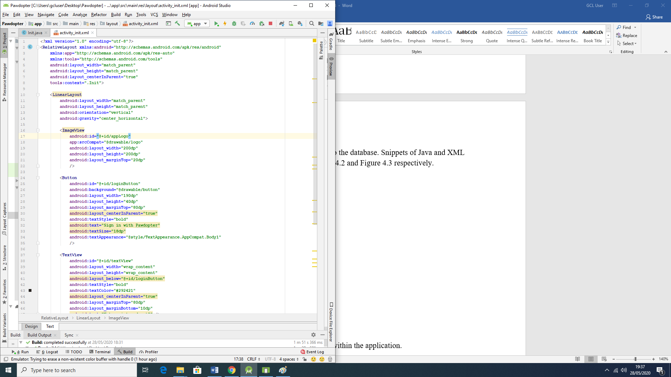

Figure 4.1b: Snippets of Code for Application Screen 1: Home Screen

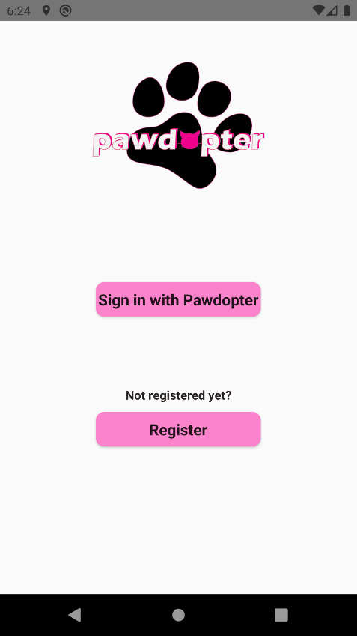

Figure 4.1c: Snapshot of the Actual Application Screen 1: Home Screen

The wireframe and the actual screen differ on where the *title* and *logo* of the app appears. In the wireframe the *logo* is set to be at the top left corner of the screen and the *title* right beside it, as a pattern for all screens. However, for aesthetics reasons, it was decided to place the *logo*, which already contains the name/title of the app, aligned on top centre of the screen.

**4.2 Screen 2: *Login* Screen**

As with the *Home* Screen, the *Login* Screen is quite simple, consisting of two fields to be filled: *Username* and *Password*. This information is to be provided at *Registration* point and placed as user record in the application database. The database holds these details about each user, and they can be retrieved and compared with the captured entries for *Username* and *Password* at *Login* point. Figure 4.2a shows the wireframe of the *Login* Screen with the 2 fields to be entered (*username* and *password*) and a button *Login* to be clicked to begin the *Login* process.

Figure 4.2b shows snippets of code (Java code to the left, and XML code to the right) for the *Login* screen, while Figure 4.2c presents the actual application Screen 2: *Login* Screen.

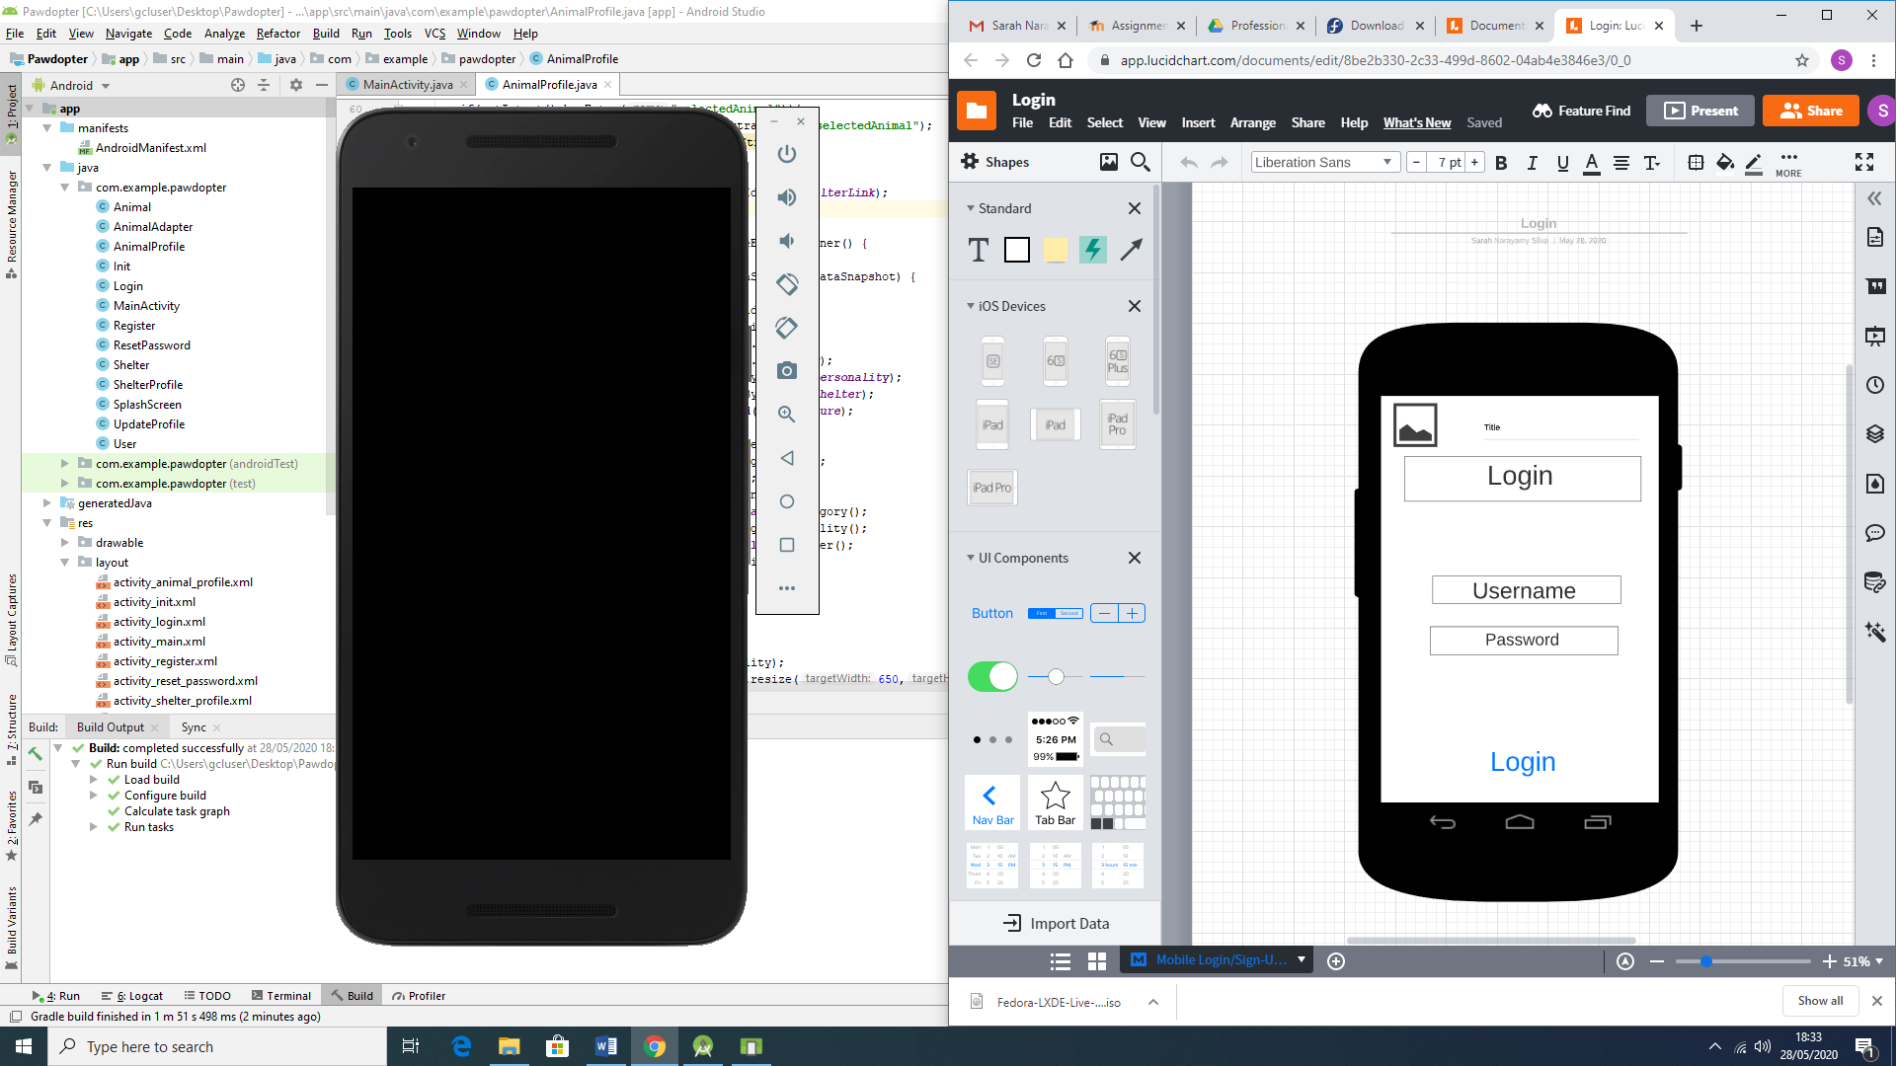

Figure 4.2a: Wireframe for Application Screen 2: Login Screen

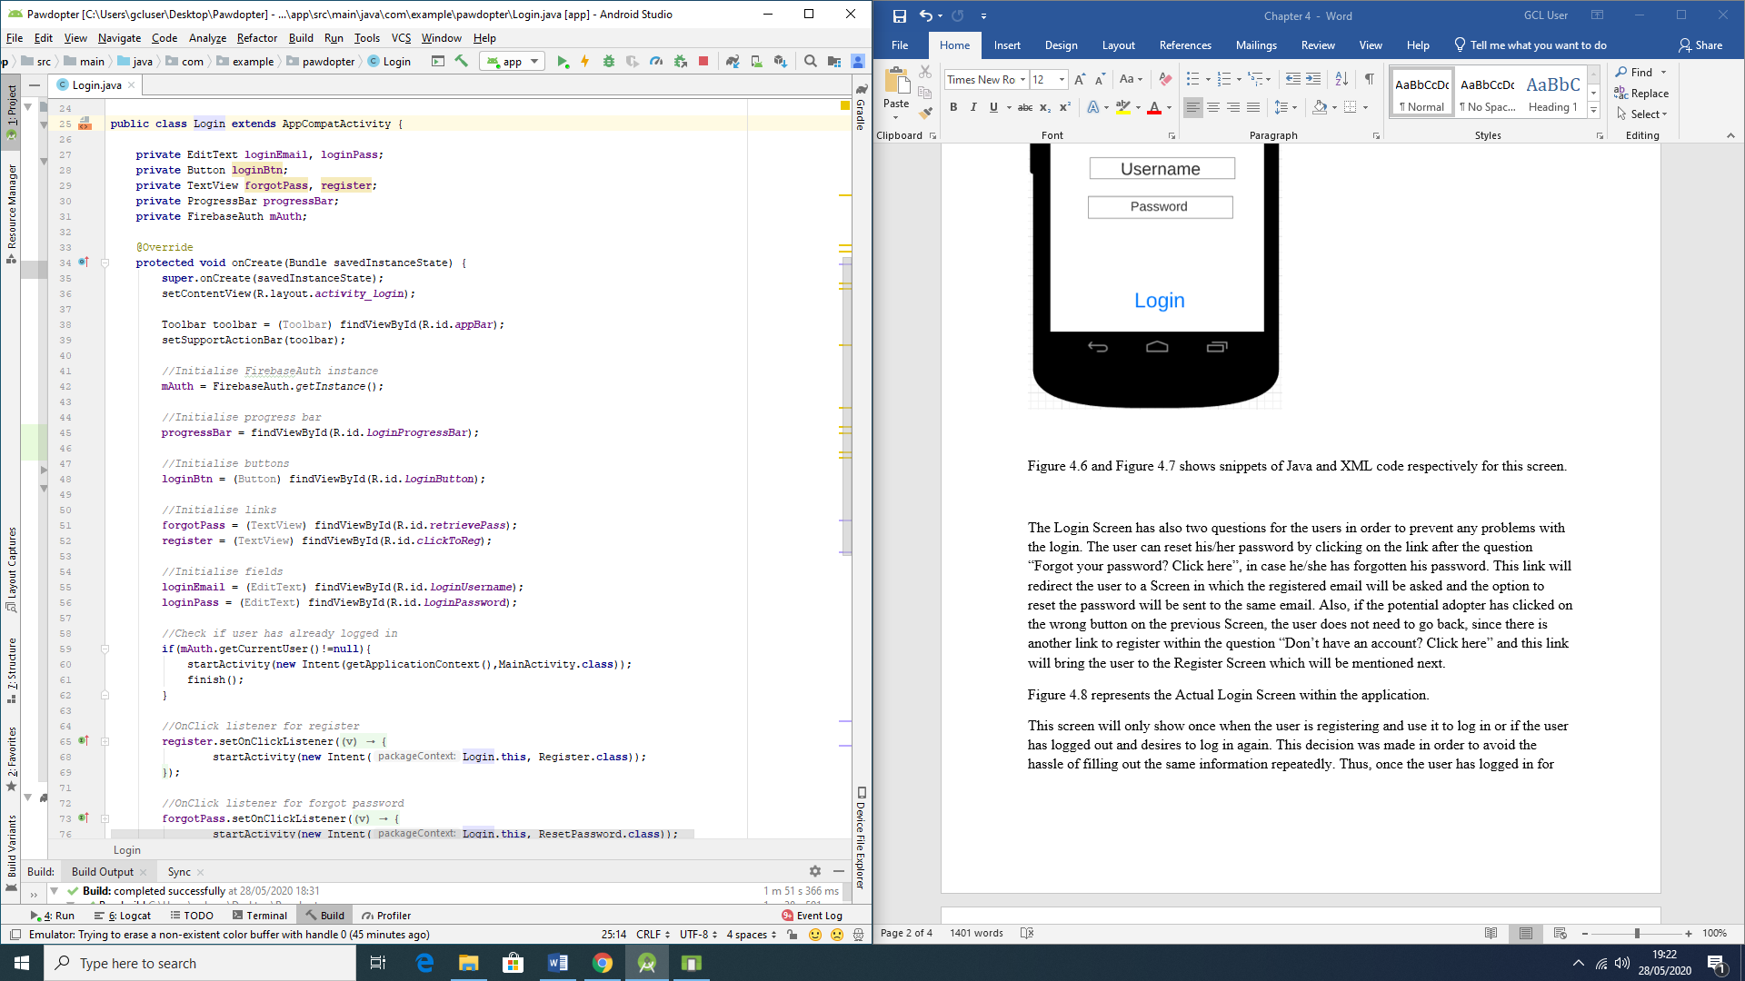 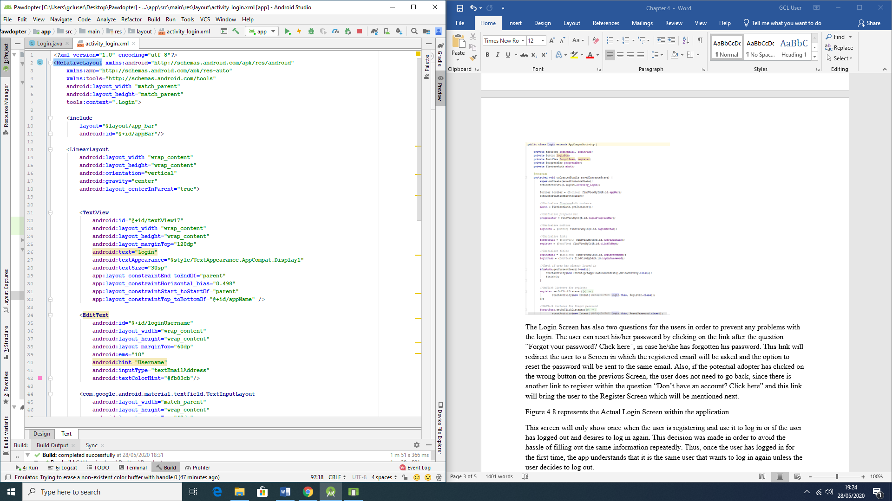

Figure 4.2b: Snippets of Code for Application Screen 2: Login Screen

There are also two links on the *Login* Screen: “*Forgot your password? Click here*” link (in case the user has forgotten their password, they can *reset* it by clicking on that link, which will redirect the user to a screen where they need to type their registered email address and a *reset password* link will be sent to that same email), and “*Don’t have an account? Click here*” link (if the potential adopter has clicked on a wrong link at the previous screen, this link will bring the user to the *Registration* Screen to properly register with the application).

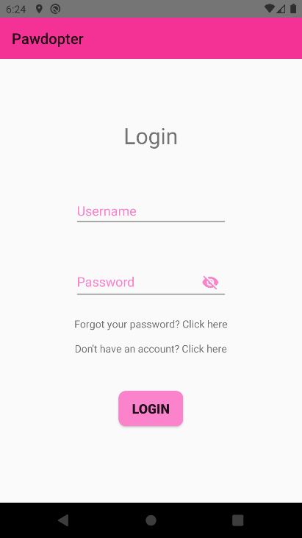

Figure 4.2c: Snapshot of the Actual Application Screen 2: Login Screen

As with the *Home* Screen, the wireframe of the *Login* Screen and the actual application screen differ where the *title* and *logo* of the app should be, and as explained for the previous screen, due to aesthetics reasons, it was decided to display only the title of app on the top left corner. There are also the added links in case of *forgotten password* and for *registration* (*creating an account*), without having to go back to the previous screen to do so.

**4.3 Screen 3: *Registration* Screen**

The *Registration* Screen is very important, since it will collect the data needed from the potential adopter, which data will be recorded in the application database. The information to be captured on this screen consists of *Name* of the user (which is needed in order to deal with the user in a direct and respectful way, by using their name, for example, “Welcome Sarah”; *Phone Number*, which is important in order to contact the user, when necessary; *E-mail address*, which could also be used to contact the user but most importantly - to determine the *Username*, since the email address is unique for each person; *Password* chosen by the user (which should contain mixture of lower- and upper-case characters, number(s), and special character(s) and be not less than 8 characters long); *re-entered (confirmed) password*, to allow verification of entered and confirmed password.

The screen has a *Submit* button, which must be clicked, after all the fields are entered by the user. It is important to state that all the fields are *mandatory*, which means that the user will not be able *to register* if one or more fields are blank. There are also different criteria for the fields, in order to validate the information, such as mobile number (which should start with “08” in order to be validated as an Irish number, and should be 10 digit long). The e-mail address should contain the username, the @ symbol, and the domain.

Figure 4.3a illustrates the wireframe of the *Registration* Screen, consisting of the fields to be entered by the user and the *Submit* button. Figure 4.3b shows snippets of code for the screen (Java code to the left and XML code to the right), while Figure 4.3c presents snapshot of the actual application Screen 3: Registration Screen.

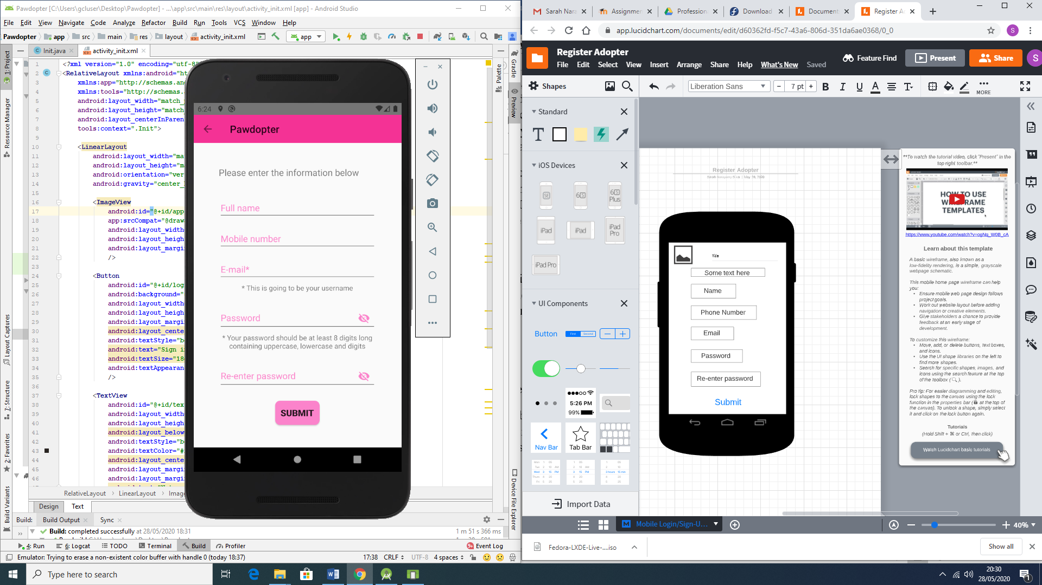

Figure 4.3a: Wireframe for Screen 3: Registration Screen

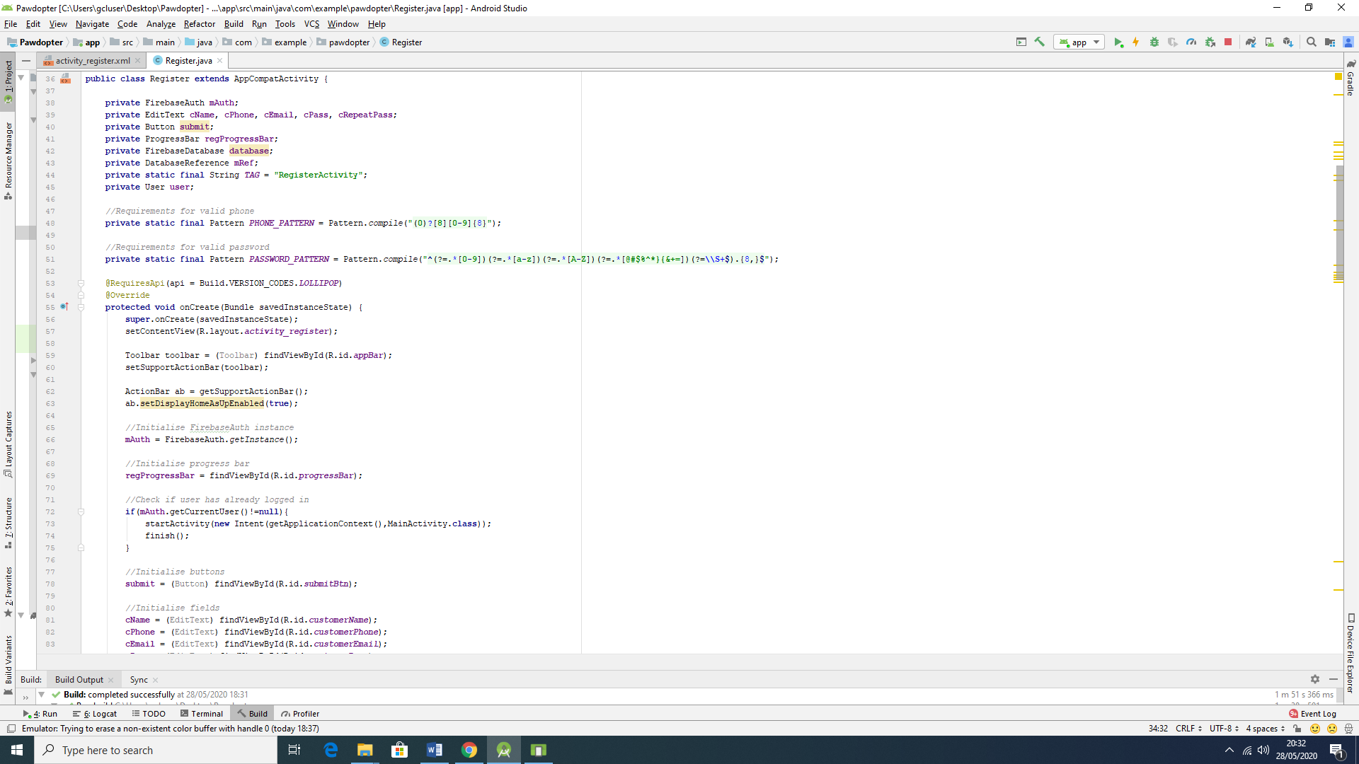 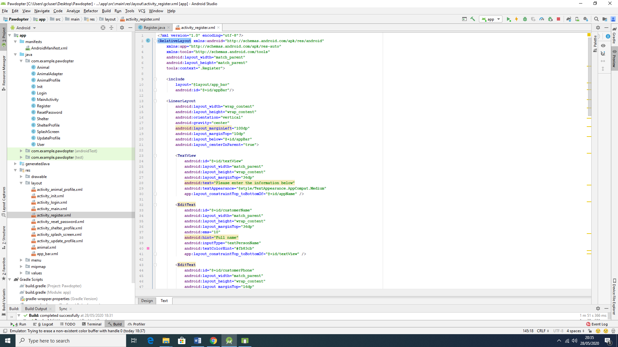

Figure 4.3b: Snippets of Code for Screen 3: Registration Screen

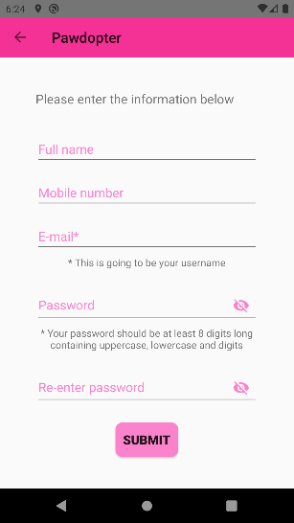

Figure 4.3c: Snapshot of the Actual Application Screen 3: Registration Screen

As with Screen 1 and 2 wireframes before, the wireframe and the actual application *Registration* screen differ for the same aspects mentioned before, related to the *logo* and *title* of the application. On this screen, the *logo* is replaced with an *arrow* pointing to the left (which implies that the user can go back to the previous screen), followed by the *title* of the app.

**4.4 Screen 4: Pets Browsing and Filtering Screen**

On this screen, the user can browse all available for adoption pets, as well as making use of the filters to search for a pet with specific characteristics. The available in the chosen sanctuary animals are each presented with their photograph, name, age, and short description of personality. Each animal entry is clickable, to reveal more detailed information about the chosen pet on another screen, designed specifically to show only that specific pet’s detailed information.

The animals can be filtered by *category* (choosing what type of animal is desired (dog, cat, etc.)), followed by *size* (small, medium or large animal), and lastly - by *breed,* (as per stored breeds of available animals in the app’s database). It is important to emphasize that these filters are nested and dependent on each other. Once the filtering is done by the user, the *Browse* screen will only show pets that correspond to the filter(s) characteristics, specified by the user.

Another important aspect of this screen is that it provides a menu for the user to *Update* their profile, or to *Logout*. This menu, once clicked, redirects the user to the respected different screens, accordingly.

Figure 4.4a illustrates the wireframe for the *Pet Browsing and Filtering* screen. Figure 4.4b presents snippets of code for the screen (Java code to the left, XML code to the right of the figure), while Figure 4.4c displays the actual application Screen 4: *Pet Browsing and Filtering* Screen.

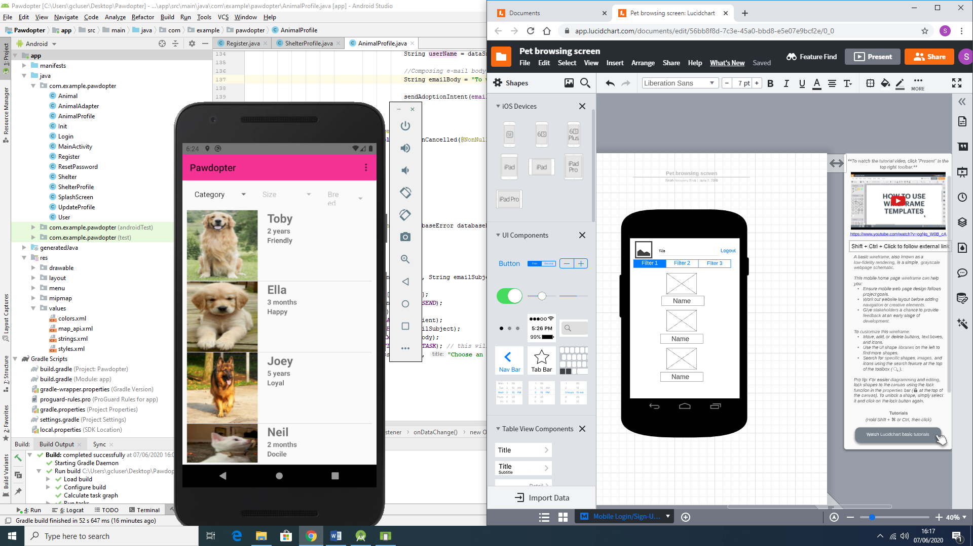

Figure 4.4a: Wireframe for Screen 4: Pet Browsing and Filtering Screen

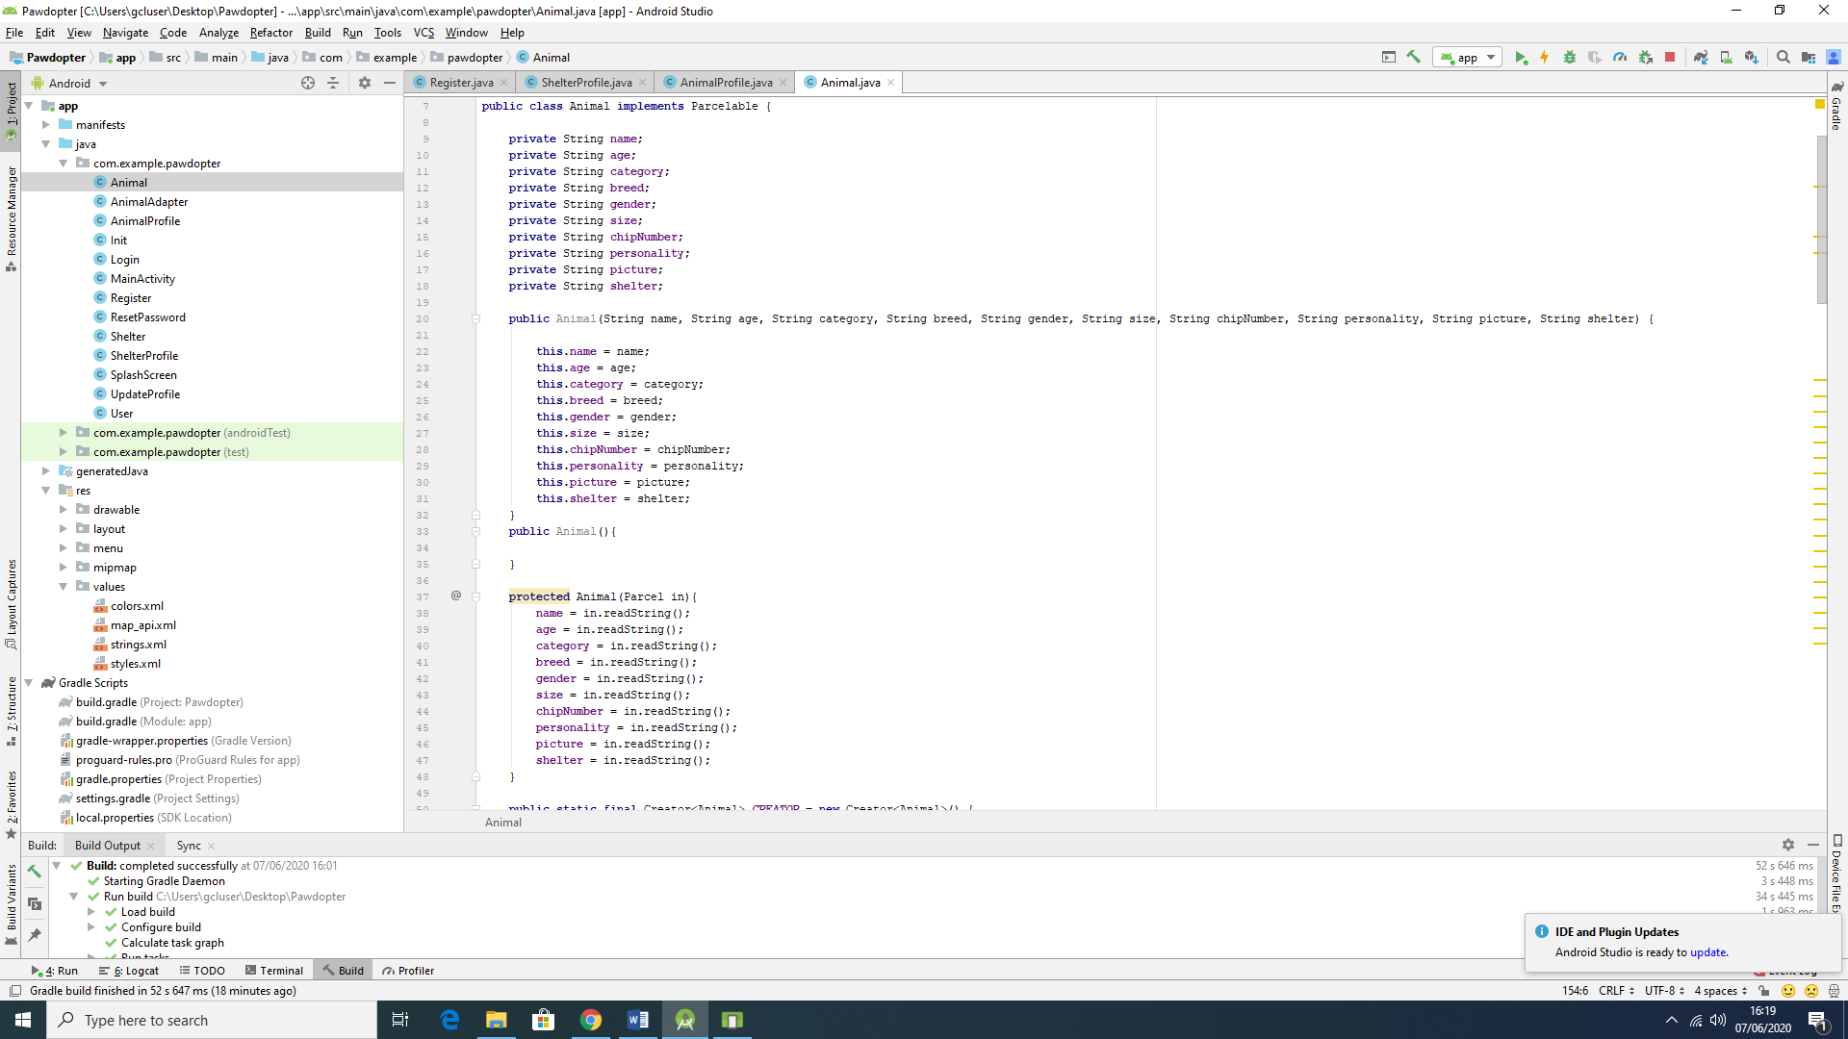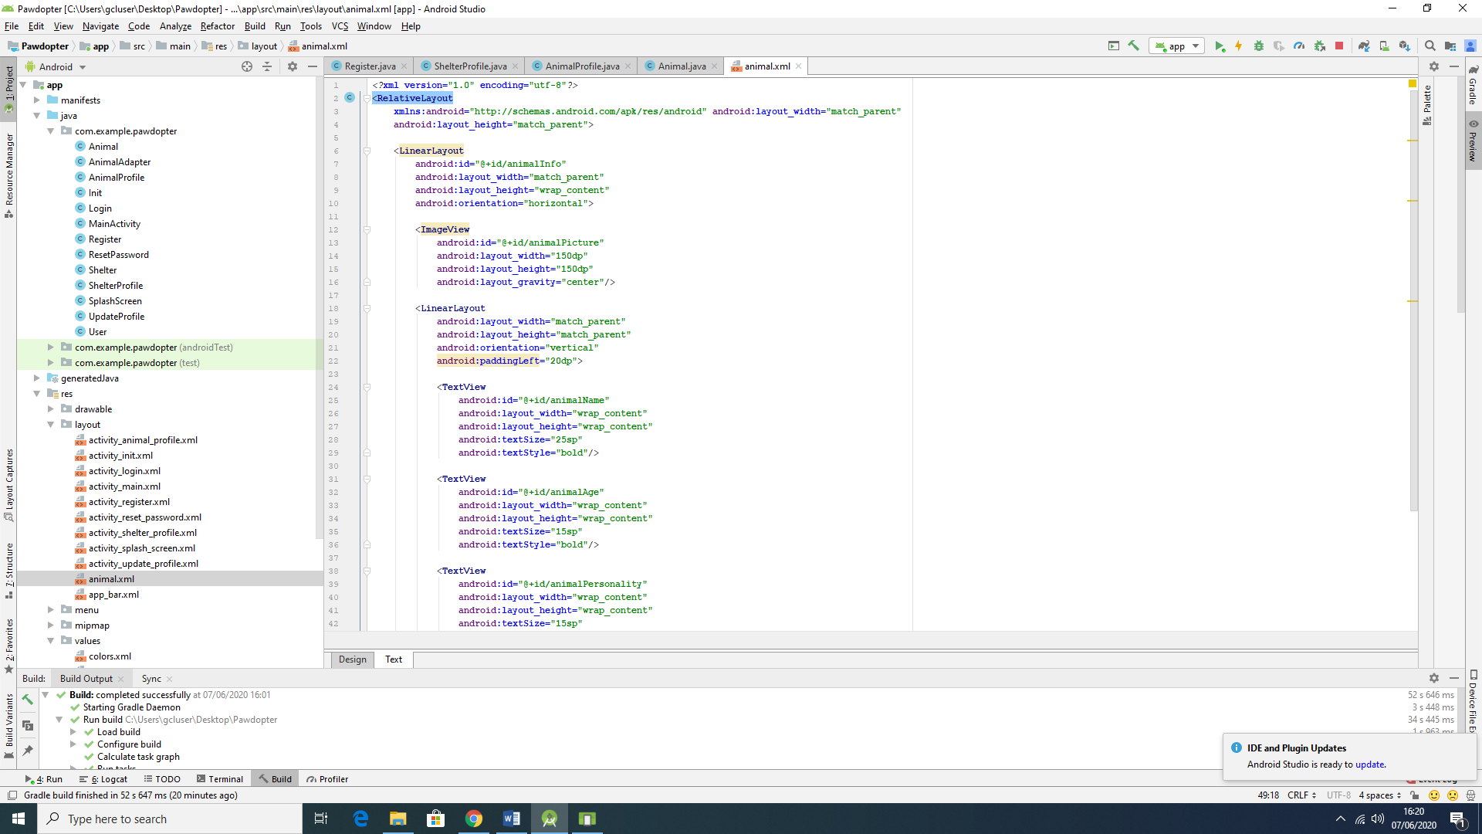

Figure 4.4b: Snippets of Code for Screen 4: Pet Browsing and Filtering Screen

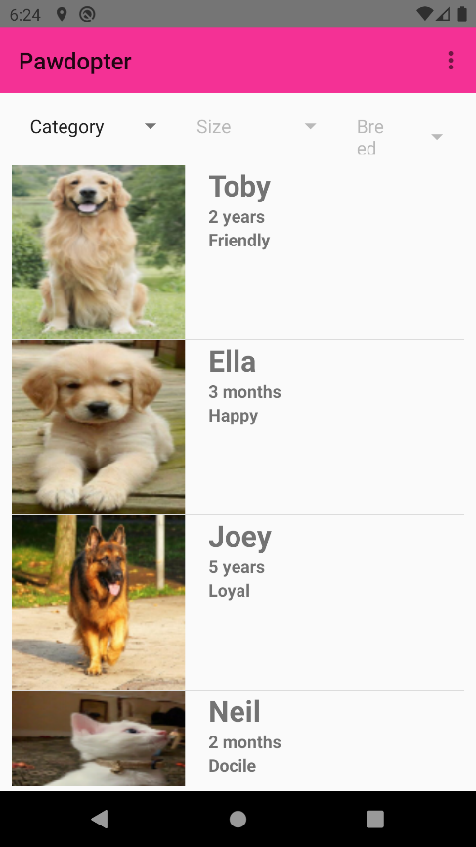

Figure 4.4c: Snapshot of the Actual Application Screen 4: Pet Browsing and Filtering Screen

The filtering process is presented with snippet of code on Figure 4.9d.

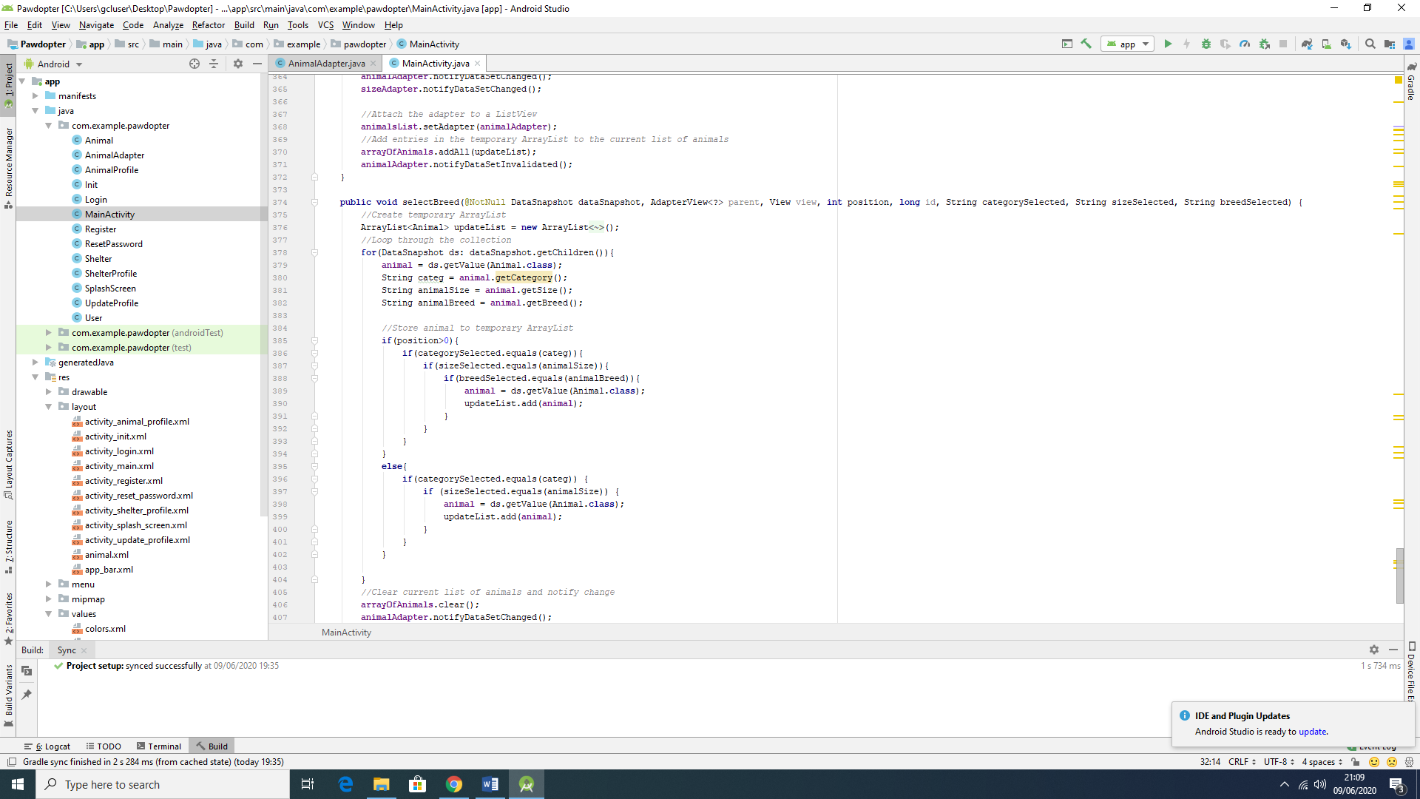

Figure 4.4d: Snippet of Code for the Filtering Process

The wireframe differs from the actual screen in many aspects. It starts by the exclusion of the *logo* on the top left corner and its replacement by presenting only the name of the application. This is followed by the menu mentioned, represented by the three bullet points in a vertical order. The Filters are kept in the same position as in the wireframe, meaning the top of the screen, right after the title of the app. However, the display of the animals is made more informative in the actual application screen, showing more information about each pet, and clear separation of the information for the different animals presented. In this case, the picture of the animal is positioned on the left side with three information sections, positioned on the right-hand side, for each animal: Name, Age, Personality.

**4.5 Screen 5: *Update User Profile* Screen**

This screen is similar with the *Registration* screen, except here the user can update its information in some of the entry fields. There are few entry fields, where information cannot be changed, such as *Name* and *E-mail*, since they are unique to each user. Thus, on this screen, the user can change their contact *mobile number* and the *password*, according to the specifications for each field, as previously discussed for the *Registration* screen. Once the *Save* button is clicked, all the information changed will be updated in the application’s *Firebase* real time database.

Figure 4.5a illustrates the wireframe for the *Update User Profile* Screen, Figure 4.5b shows snippets of code (Java code to the left, XML code to the right of the figure) for the screen, while Figure 4.5c displays snapshot of the actual application *Update User Profile* Screen. Figures 4.5d and 4.5e show *before* and *after* the information change has been reflected in database, respectively.

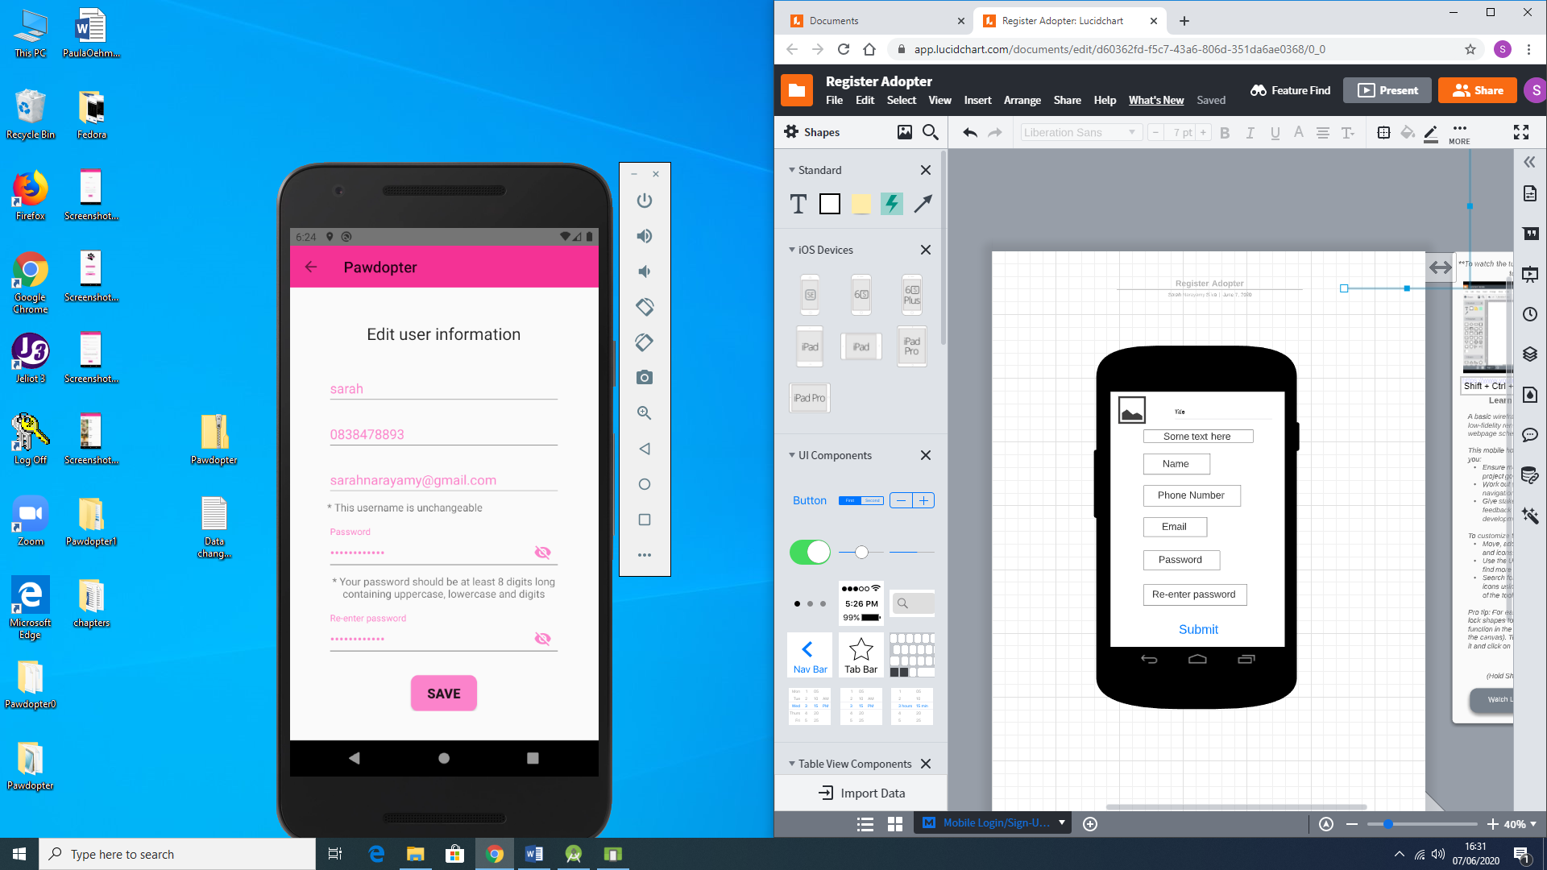

Figure 4.5a: Wireframe for Screen 5: Update User Profile Screen

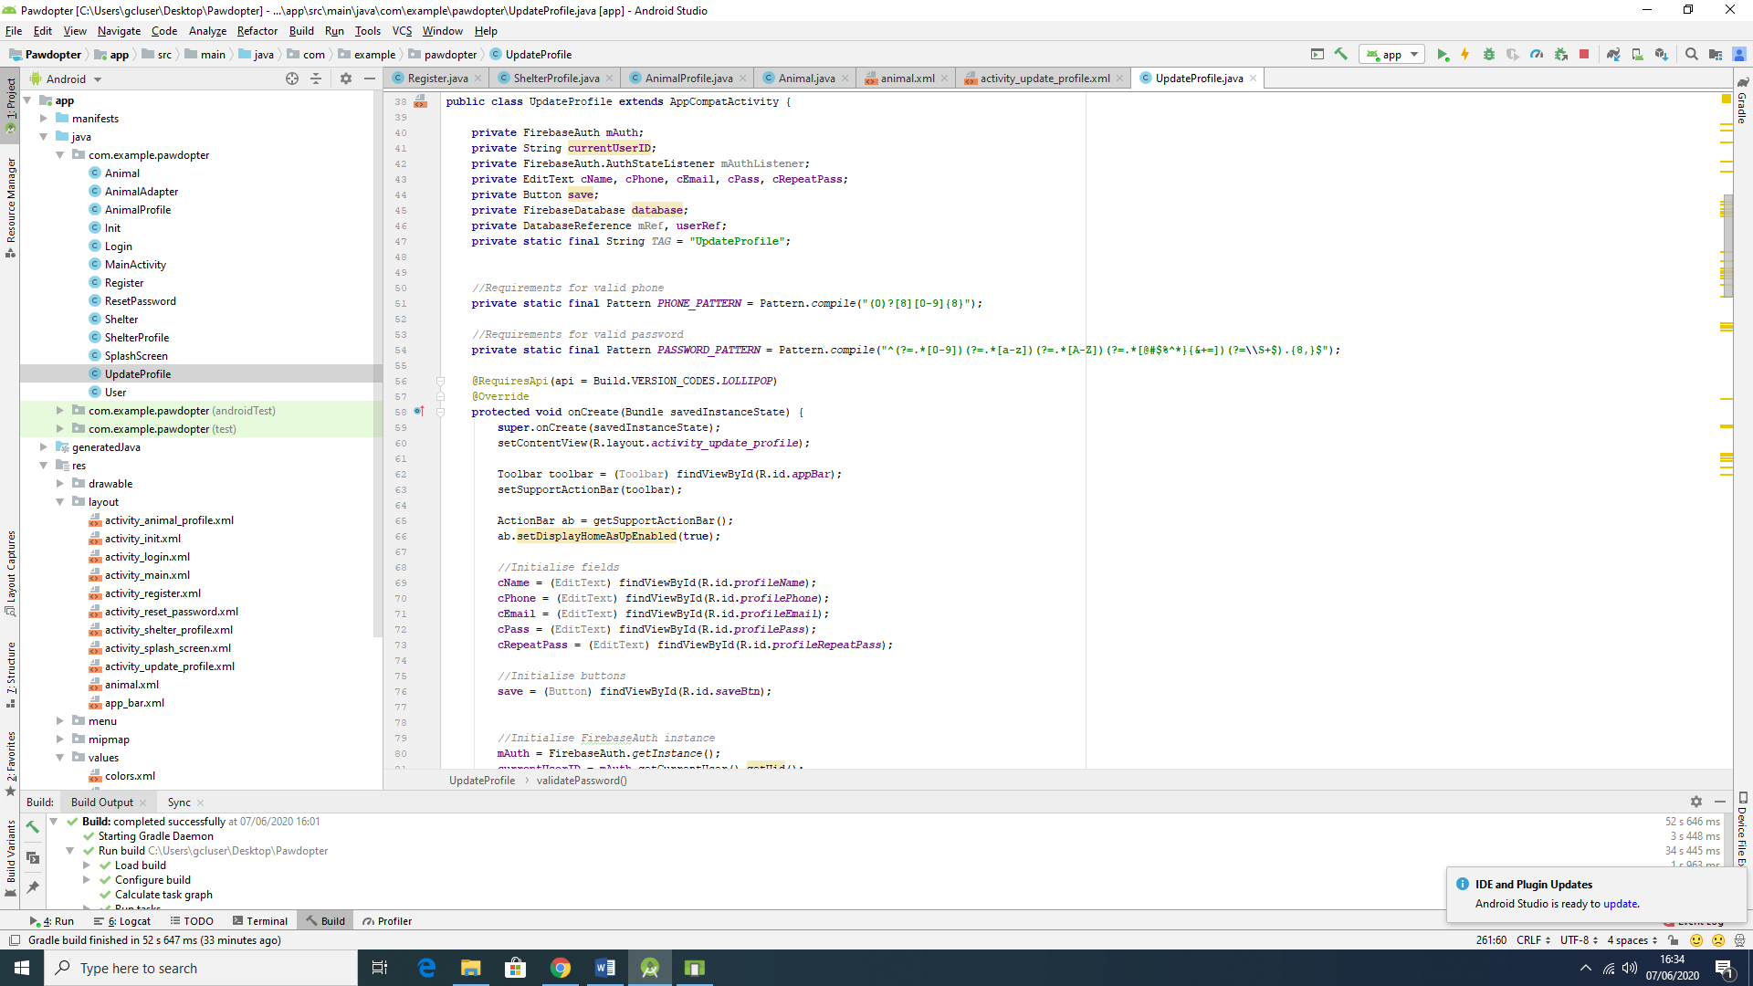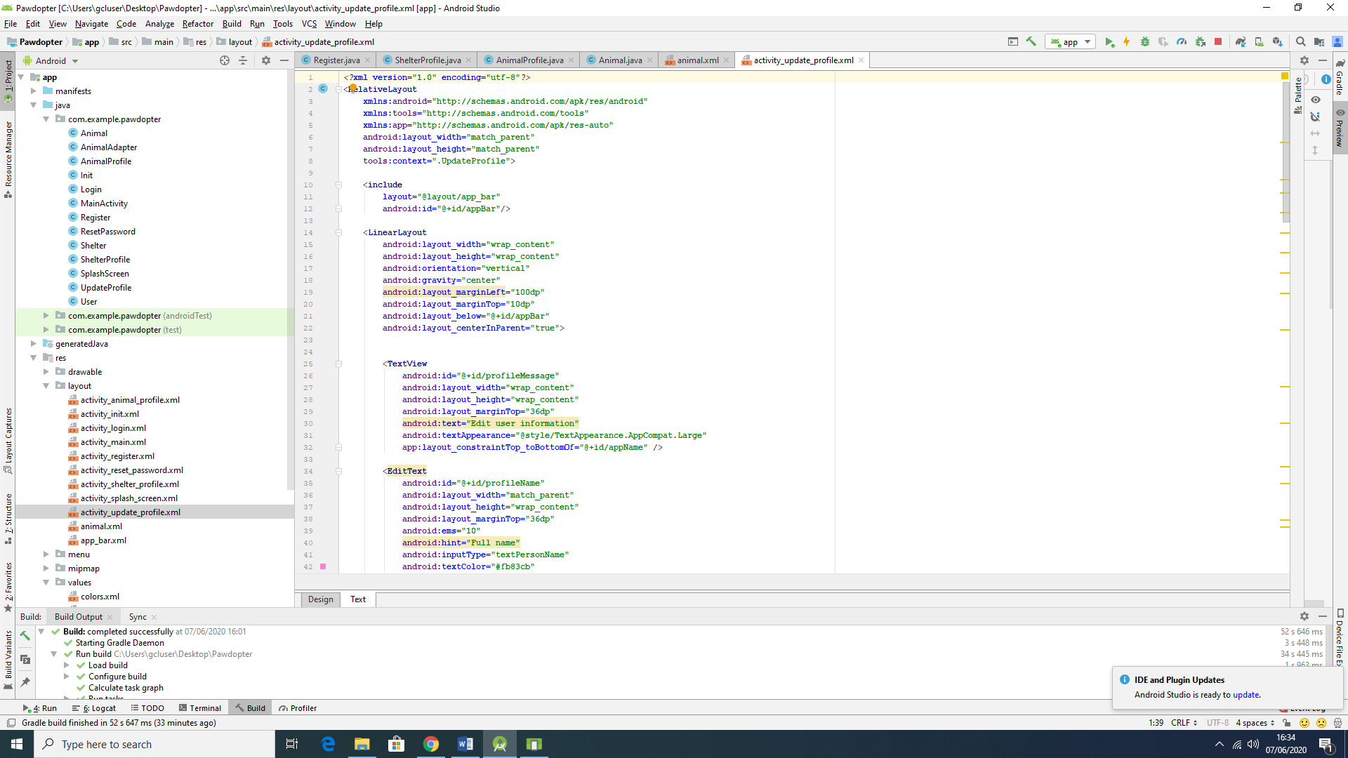

Figure 4.5b: Snippets of Code for Screen 5: Update User Profile Screen

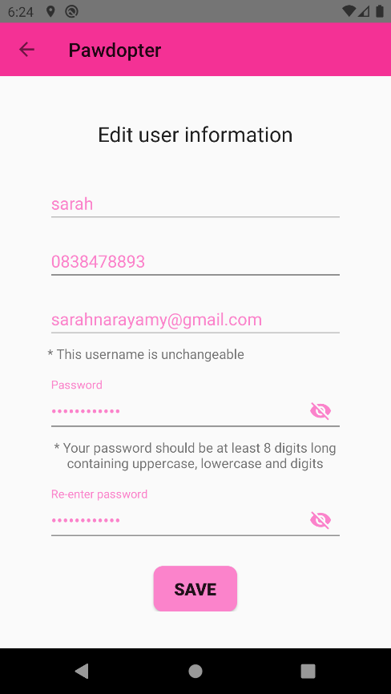

Figure 4.5c: Snapshot of the Actual Application Screen 5: Update User Profile Screen

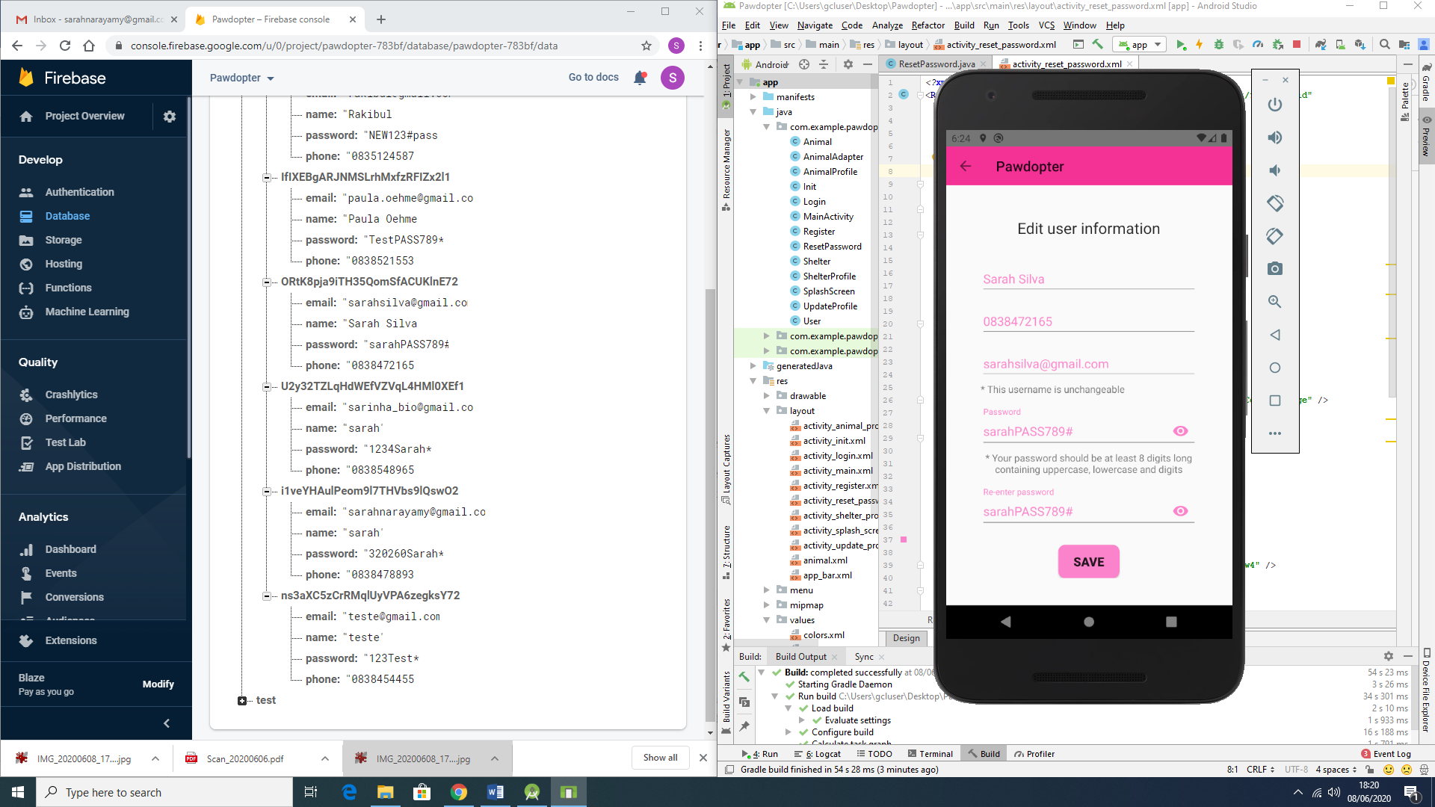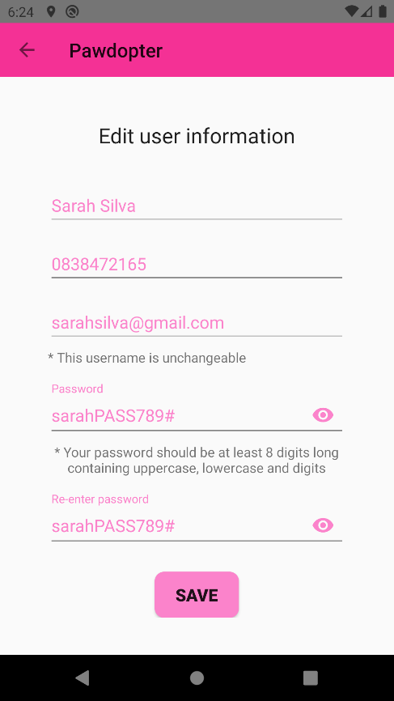

Figure 4.5d: Before the information is changed (Database on the left-hand side and snapshot of the actual screen on the right-hand side of the Figure)

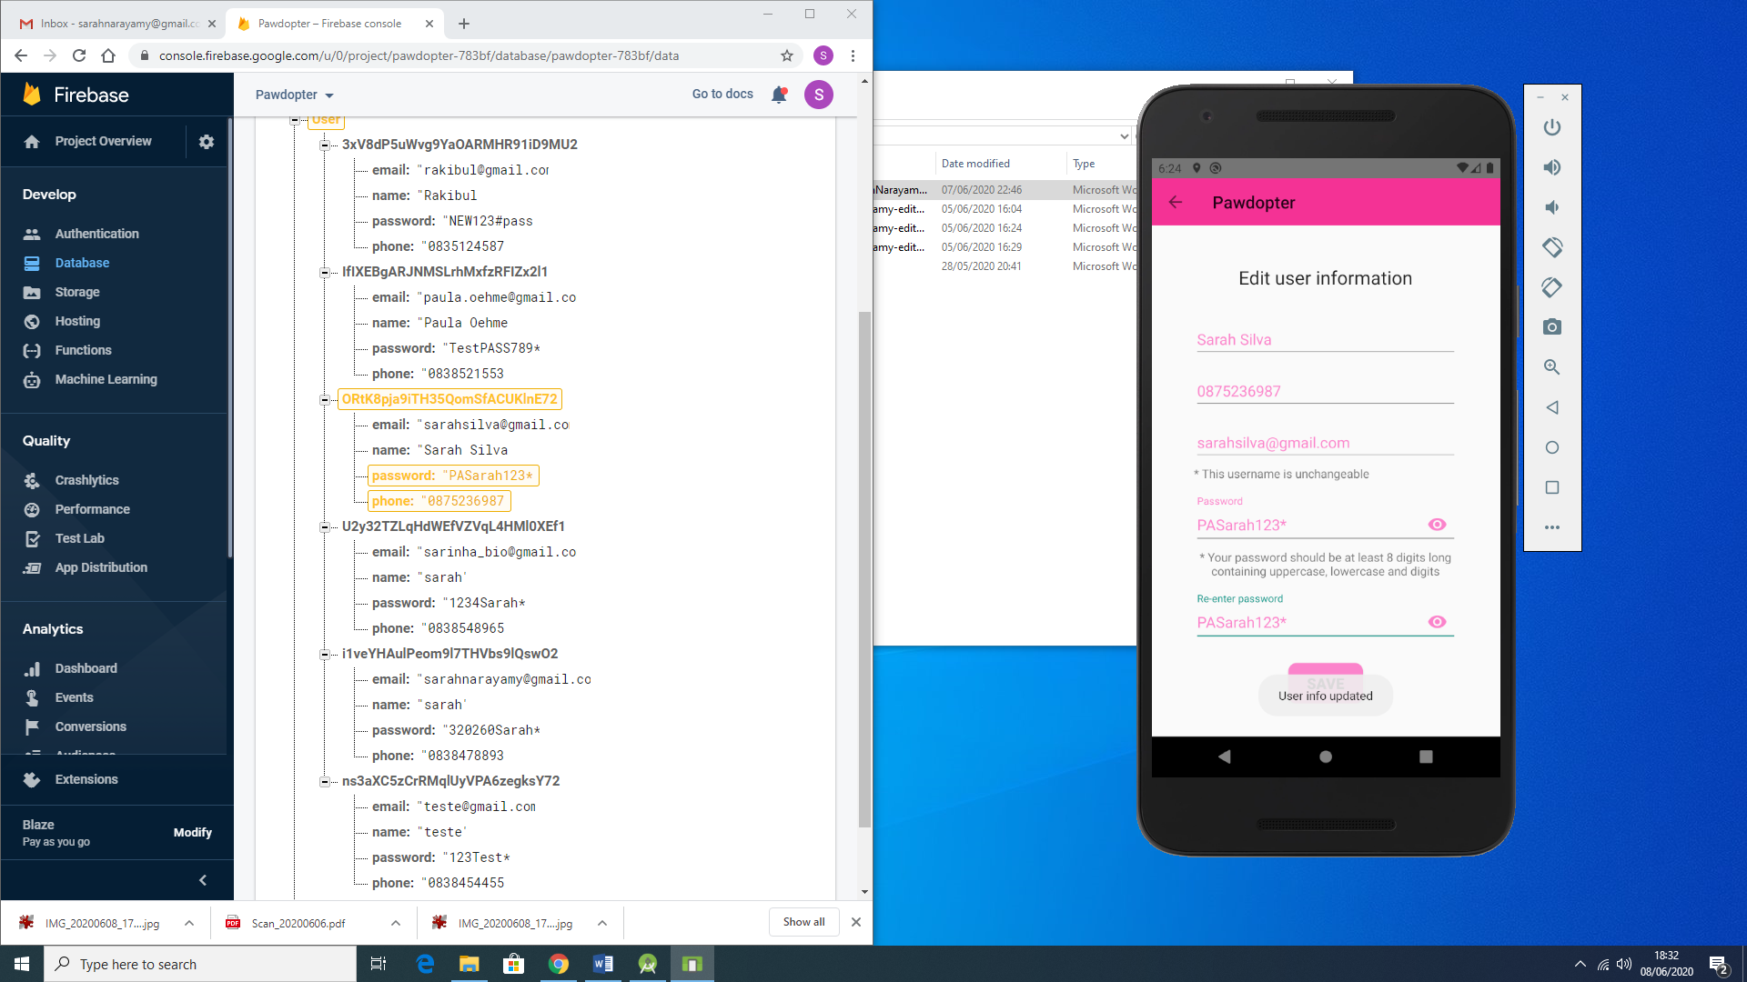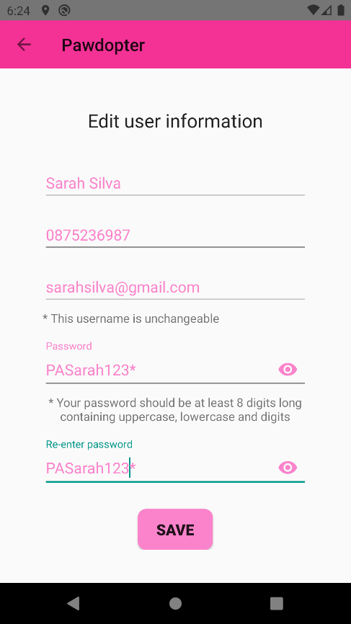

Figure 4.5e: After the information is being changed (Database on the left-hand side and snapshot of the actual screen on the right-hand side of the Figure)

**4.6 Screen 6: *Chosen Pet Visualization* Screen**

When the user clicks on a desired pet from the *Pet Browsing and Filtering* Screen (Screen 4), the user is redirect to a new screen – Chosen Pet Visualization Screen, which provides all detailed information about the chosen animal, such as: picture, name, breed, age, gender, personality, and the name of the shelter where this animal is kept.

Figure 4.6a illustrates the wireframe for the *Chosen Pet Visualization* Screen, Figure 4.6b shows snippets of code (Java code to the left, XML code to the right of the figure) for the screen, while Figure 4.6c displays snapshot of the actual application *Update User Profile* Screen.

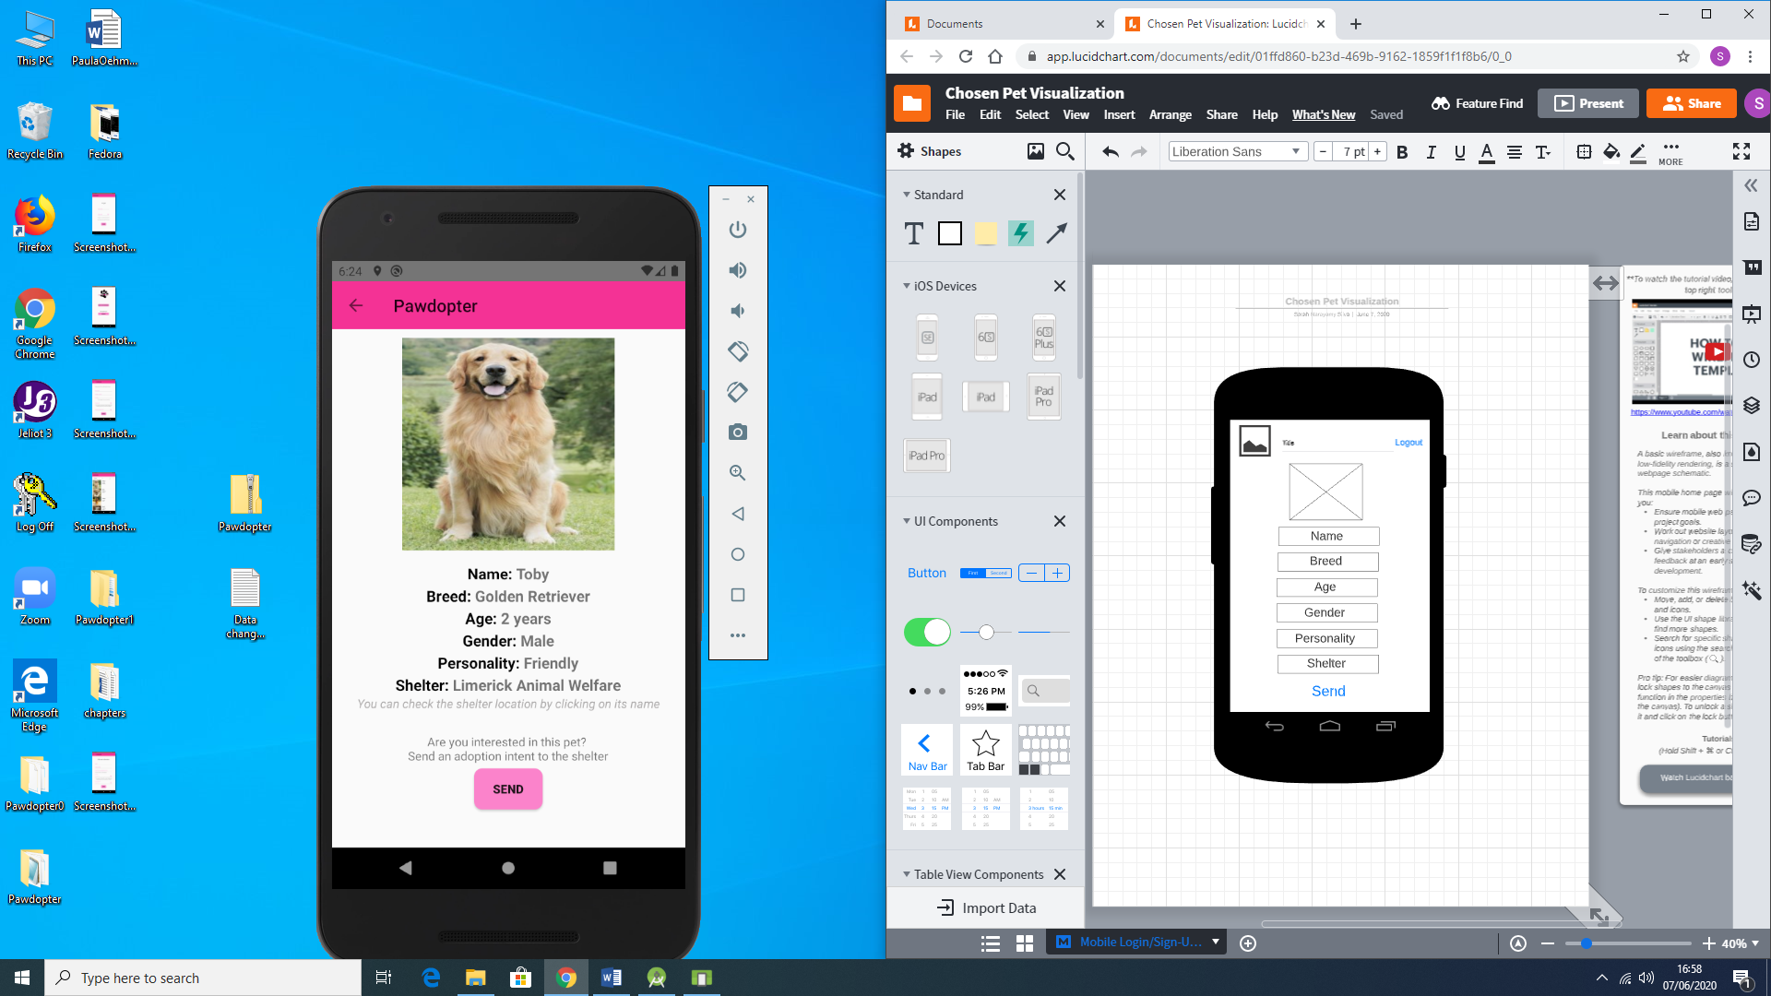

Figure 4.6a: Wireframe for Screen 6: Chosen Pet Visualization Screen

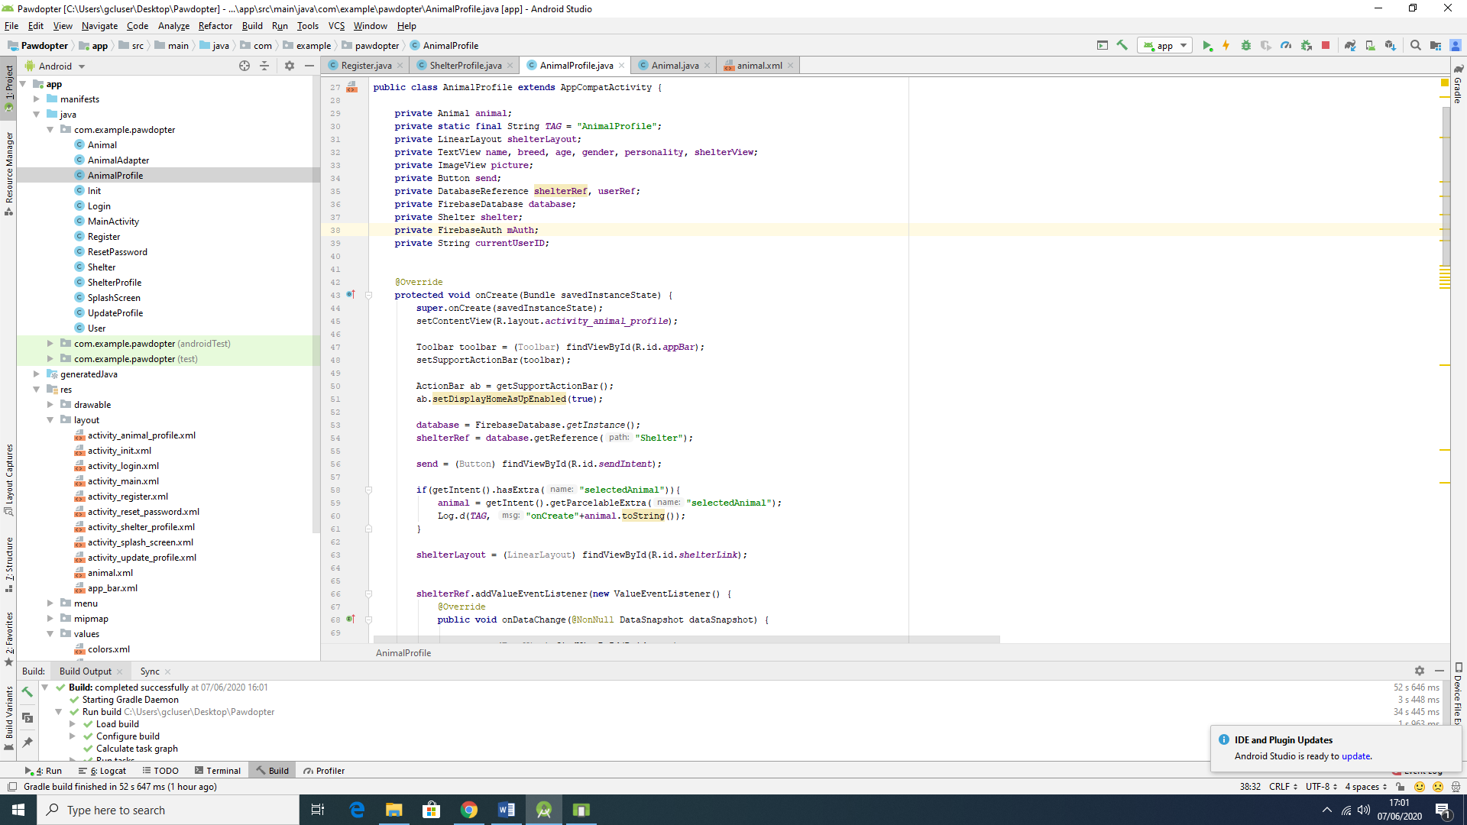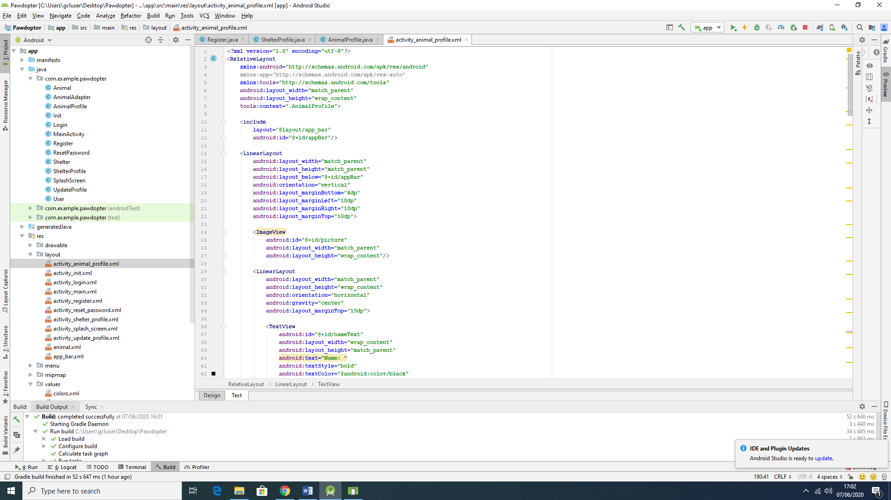

Figure 4.6b: Snippets of Code for Screen 6: Chosen Pet Visualization Screen

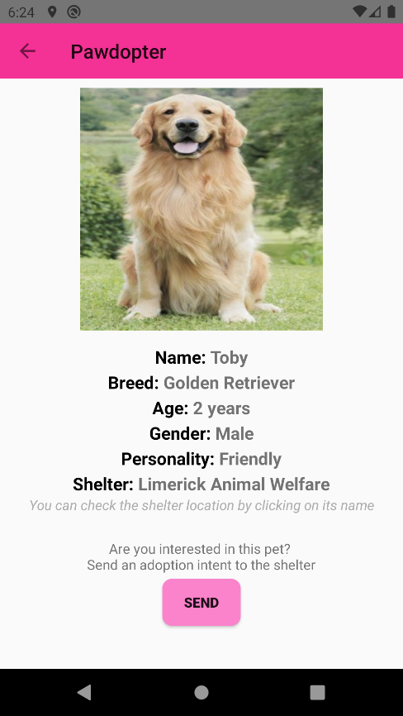

Figure 4.6c: Snapshot of the Actual Application Screen 6: Chosen Pet Visualization Screen

The actual *Chosen Pet Visualization* Screen differs from the wireframe of the screen as mentioned for the previously described screens. At the top of the screen the logo is not displayed – instead, a left arrow is used, indicating that the user can go back to the *Pet Browsing and Filtering* screen. The name of the application is displayed right beside the arrow, and at the bottom of the *Chosen Pet Visualization* Screen there is a *Send* button, which allows the user to send an *Adoption Intent* message, in an e-mail format, to the corresponding shelter where the animal is located. Also, on this screen, it was decided to make the name of the shelter clickable, so the user can see Google Maps location of the shelter with detailed contact information for the shelter. By clicking on the shelter’s name, the user will be redirected to another screen which will display the information of the shelter.

Clicking on the *Send* button, the user will be asked to select which e-mail platform will be used as an e-mail to be sent. Figure 4.6d shows the options (which should vary, according to the user’s usage (Gmail, Outlook, Yahoo mail, etc)).

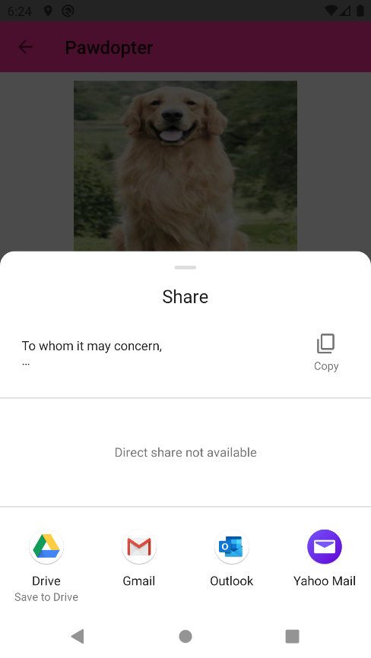

Figure 4.6d: Options to choose from to send the Intent of Adoption Form, according to the device being used

Once the option is chosen, a predefined standard e-mail template, which retrieves the information of the user and the chosen animal, is presented on screen. The user can add information on the e-mail as they are pleased, however if there is no intention on modifying it, the user should just click on the *Send* button from the e-mail. Figure 4.6e shows the pre-written e-mail. In this case, for security reasons, accordingly to the General Data Protection Act (GDPR), the application only retrieves the e-mail and the name of the user, in order to make a first contact with the shelter, however as mentioned before, the user is able of adding information, such as mobile number, or other information, as they are pleased. Figure 4.6f shows the e-mail sent to the shelter and followed by the e-mail received from the shelter in response, with a date and time for visiting the sanctuary.

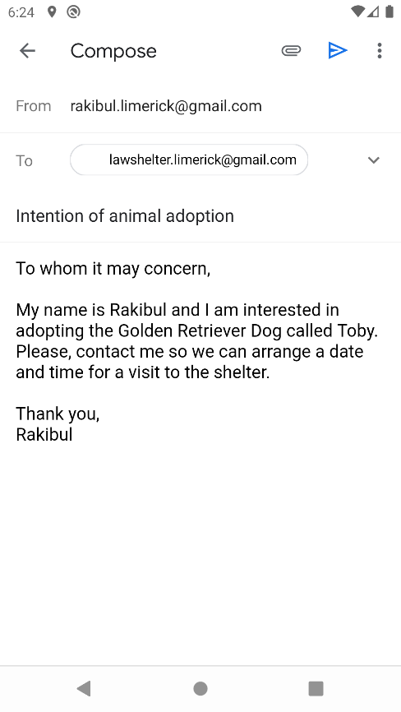 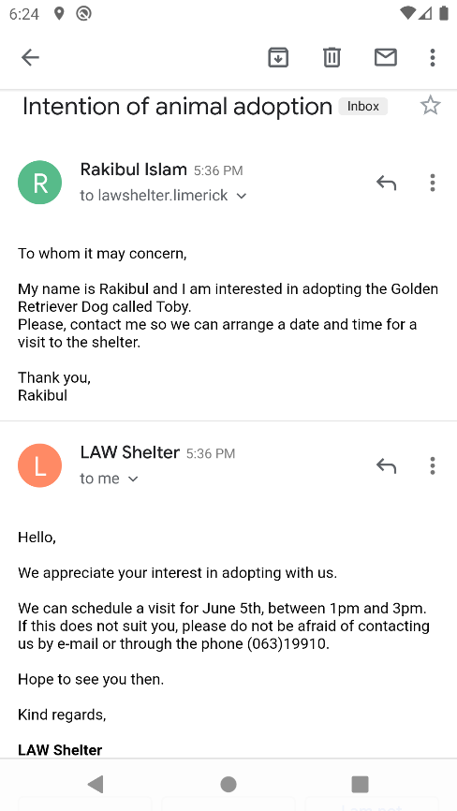

Figure 4.6e: Sample of pre-written e-mail sent by user on the left-hand side, and the e-mail response from the shelter on the right-hand side of the figure

**4.7 Screen 7: *Shelter Information* Screen**

The *Shelter Information* screen, as the name says, provides information as stored in the database about specific shelter, such as name, phone number, physical address, and e-mail address. There is also a back button, to allow user to go back to the previous screen, which is the *Chosen Pet Visualization* Screen, and view the pet information once again.

Figure 4.7a presents the wireframe for the *Shelter Information*Screen, Figure 4.7b shows snippets of code (Java code to the left-hand side, XML code to the right-hand side of the figure) for the screen, while Figure 4.7c displays snapshot of the actual application *Shelter Information* Screen.

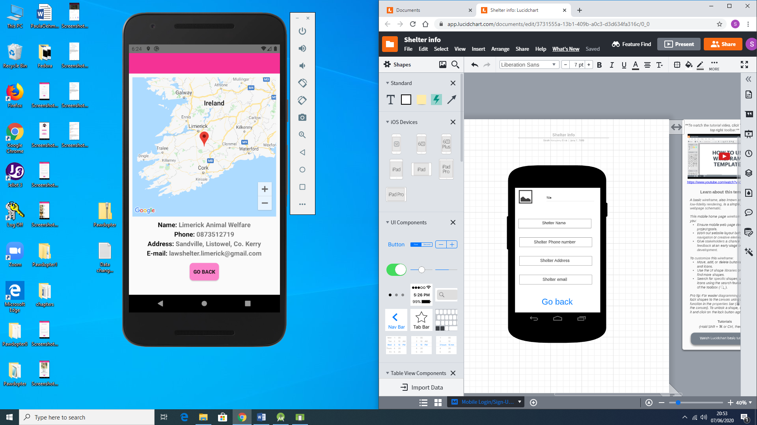

Figure 4.7a: Wireframe of Screen 7: Shelter Information Screen

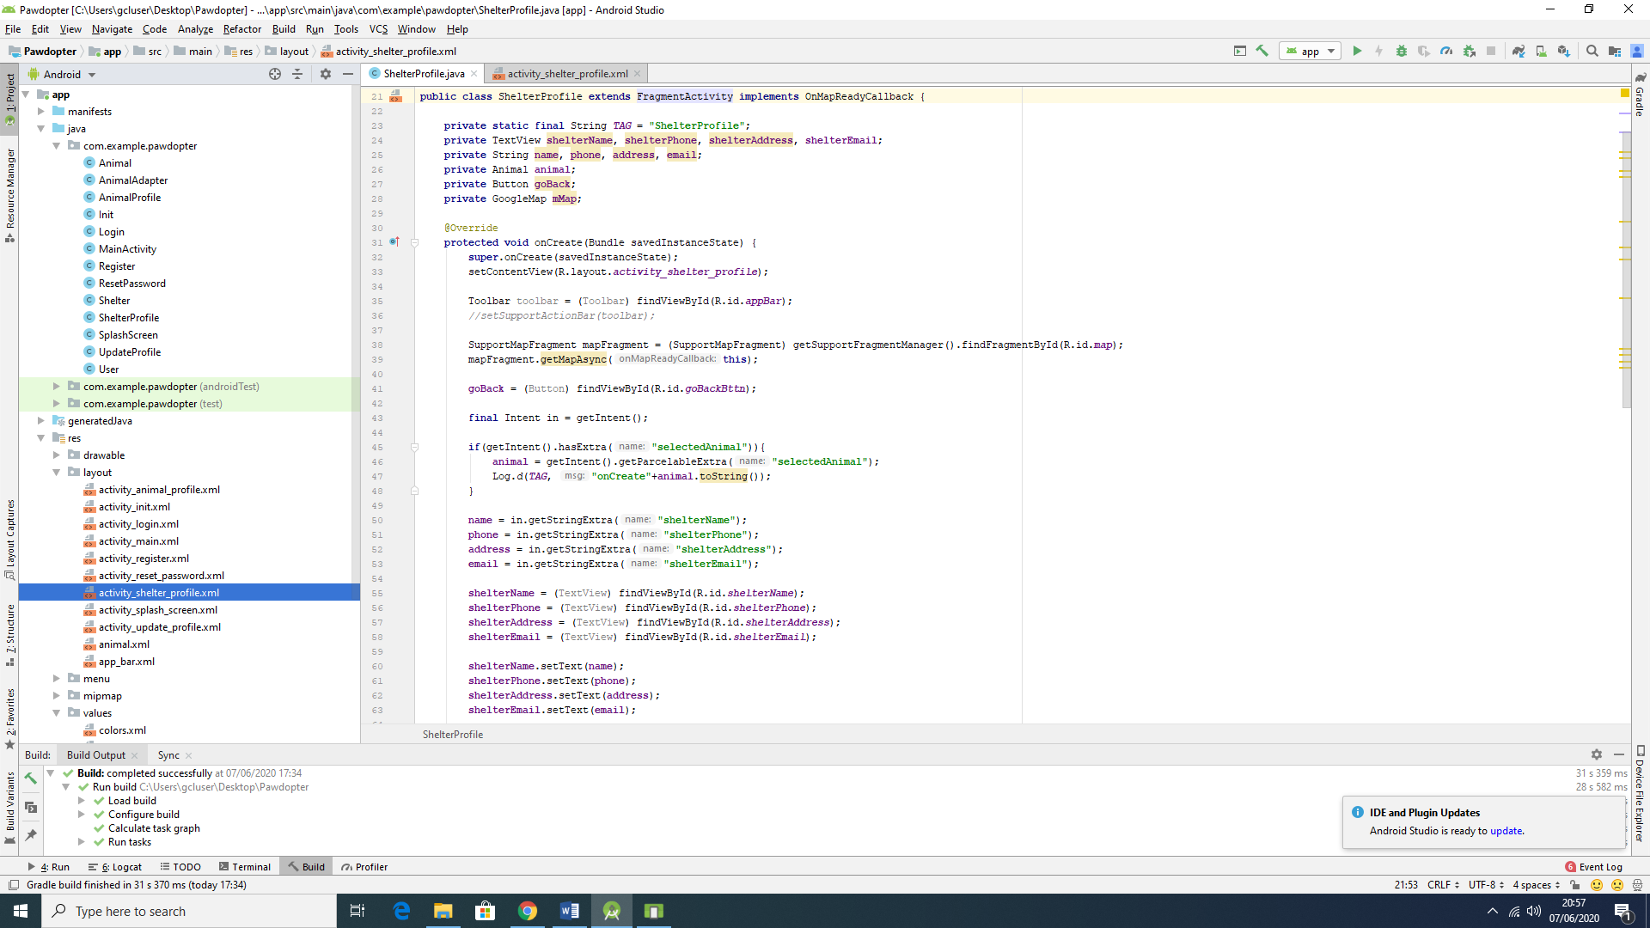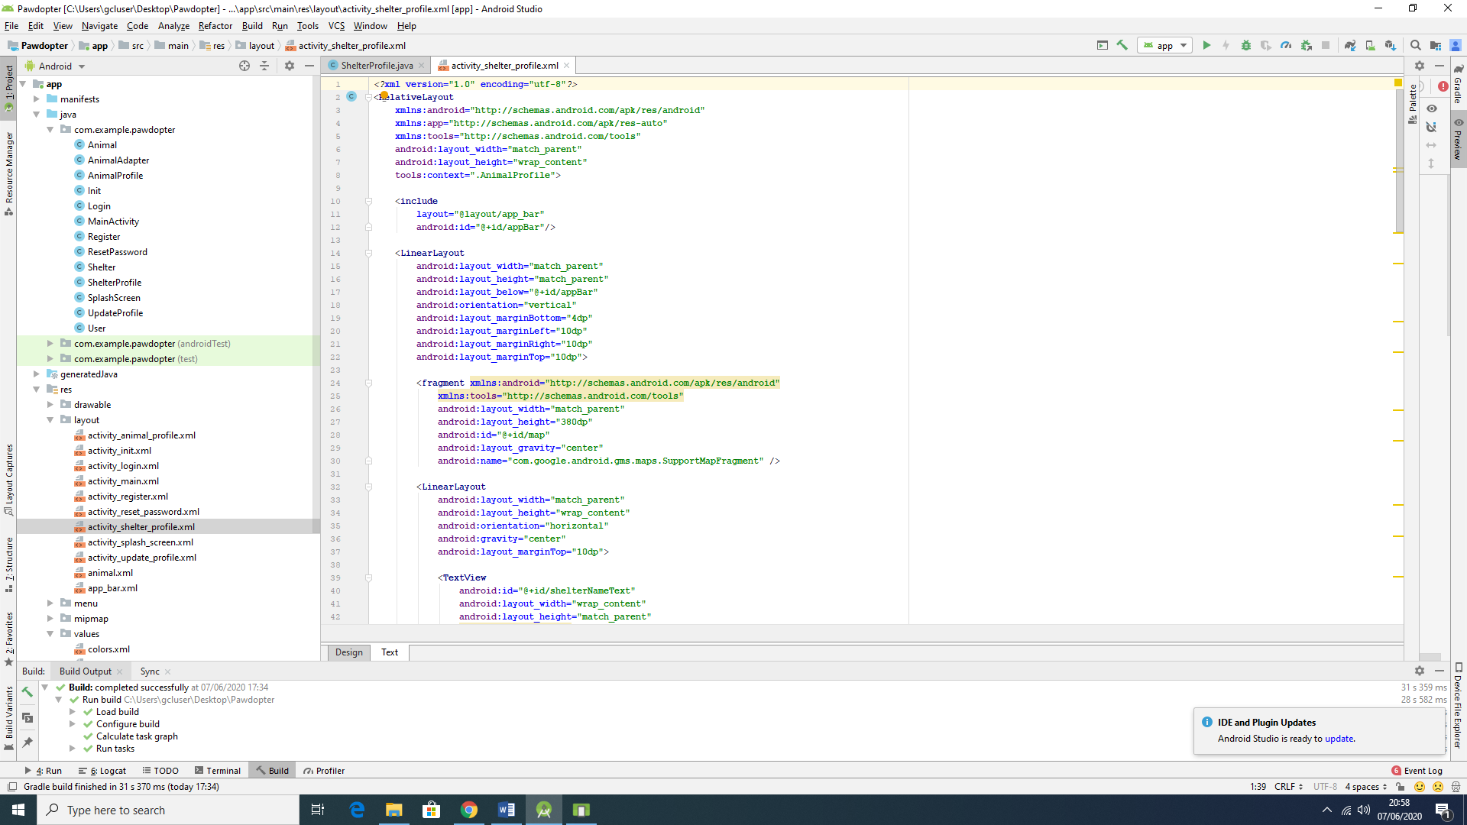

Figure 4.7b: Snippets of Code for Screen 7: Shelter Information Screen

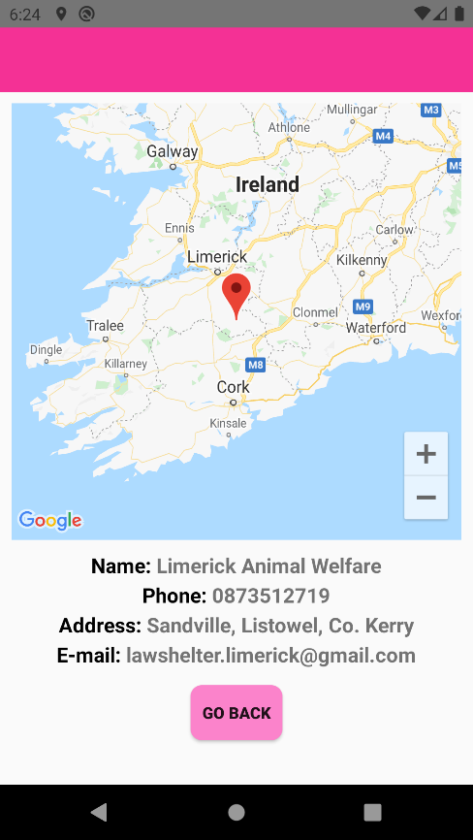

Figure 4.7c: Snapshot of the Actual Application Screen 7: Shelter Information Screen

The wireframe and the actual screen differ - a Google Maps image with the location of the shelter is presented on the actual screen, which means that the user can not only view textual information about the shelter, but can see the actual physical location of the shelter on the map, and calculate the distance to their location. This image is placed above all written information about the shelter.

**4.8 Screen 8: *Reset Password* Screen**

The *Reset Password* Screen presents the *Reset Password* process, which is as simple as it can be. It provides a field to type the user’s e-mail address, as provided during the registration process, and *Reset* button to activate the resetting password. Once the user clicks on the button, an automatic e-mail is generated by the app and sent to the user’s address.

Figure 4.8a illustrates the wireframe for the *Reset Password* Screen, Figure 4.8b shows snippets of code (Java code to the left, XML code to the right of the figure) for the screen, while Figure 4.8c displays snapshot of the actual application *Reset Password* Screen.

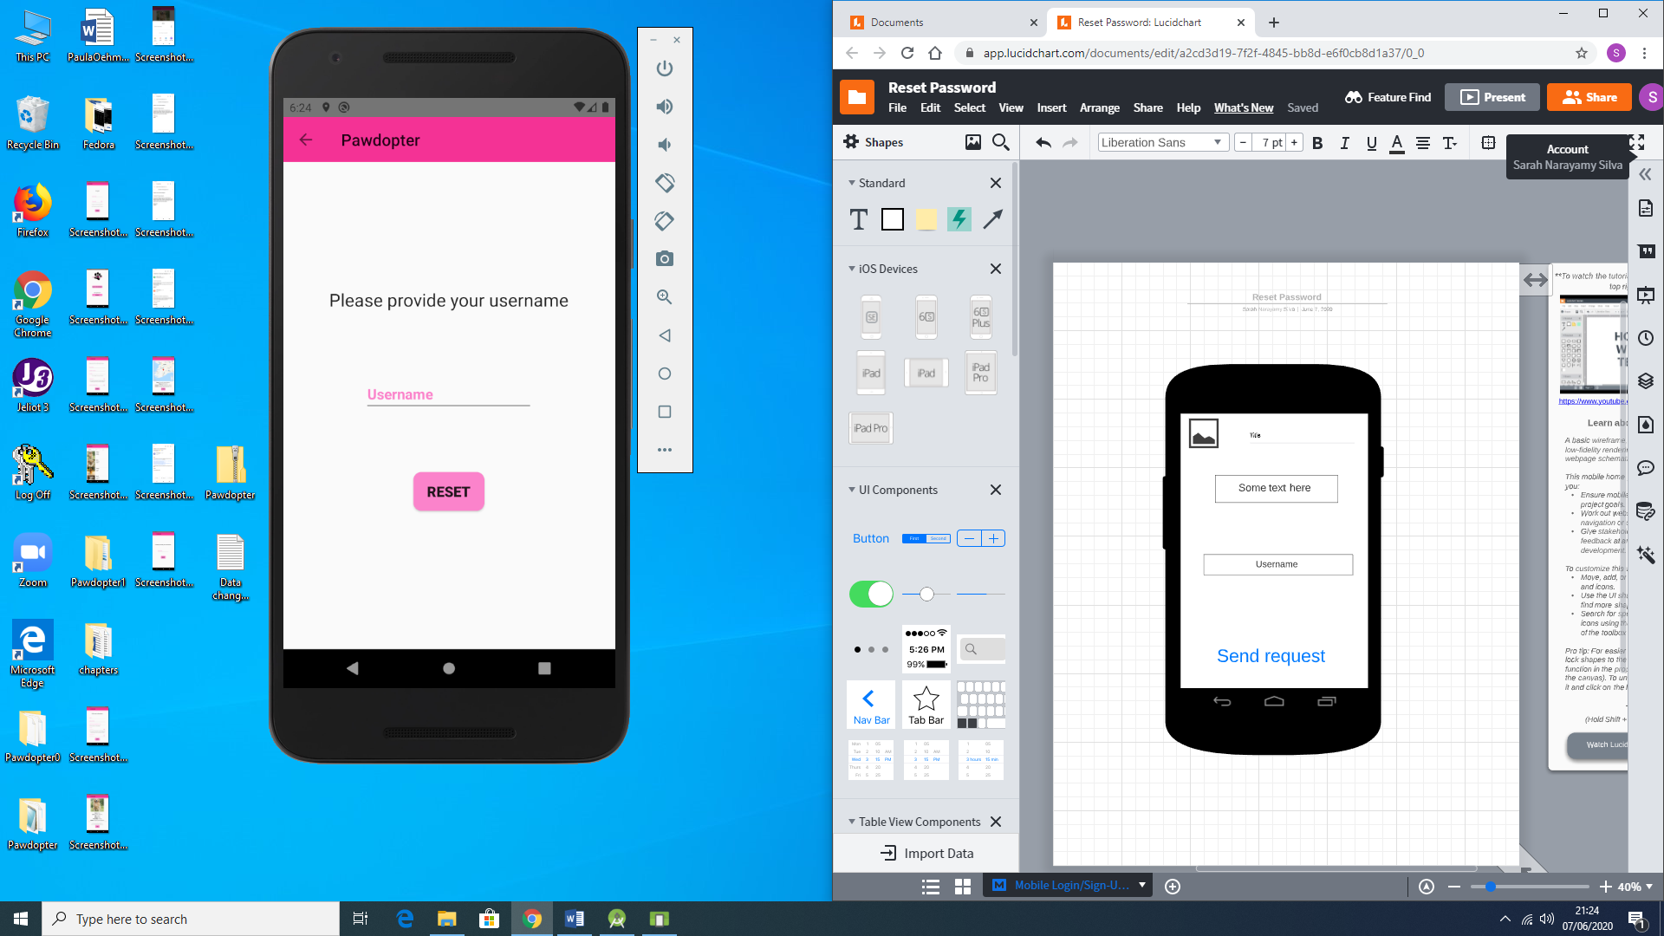

Figure 4.8a: Wireframe of Screen 8: Reset Password Screen

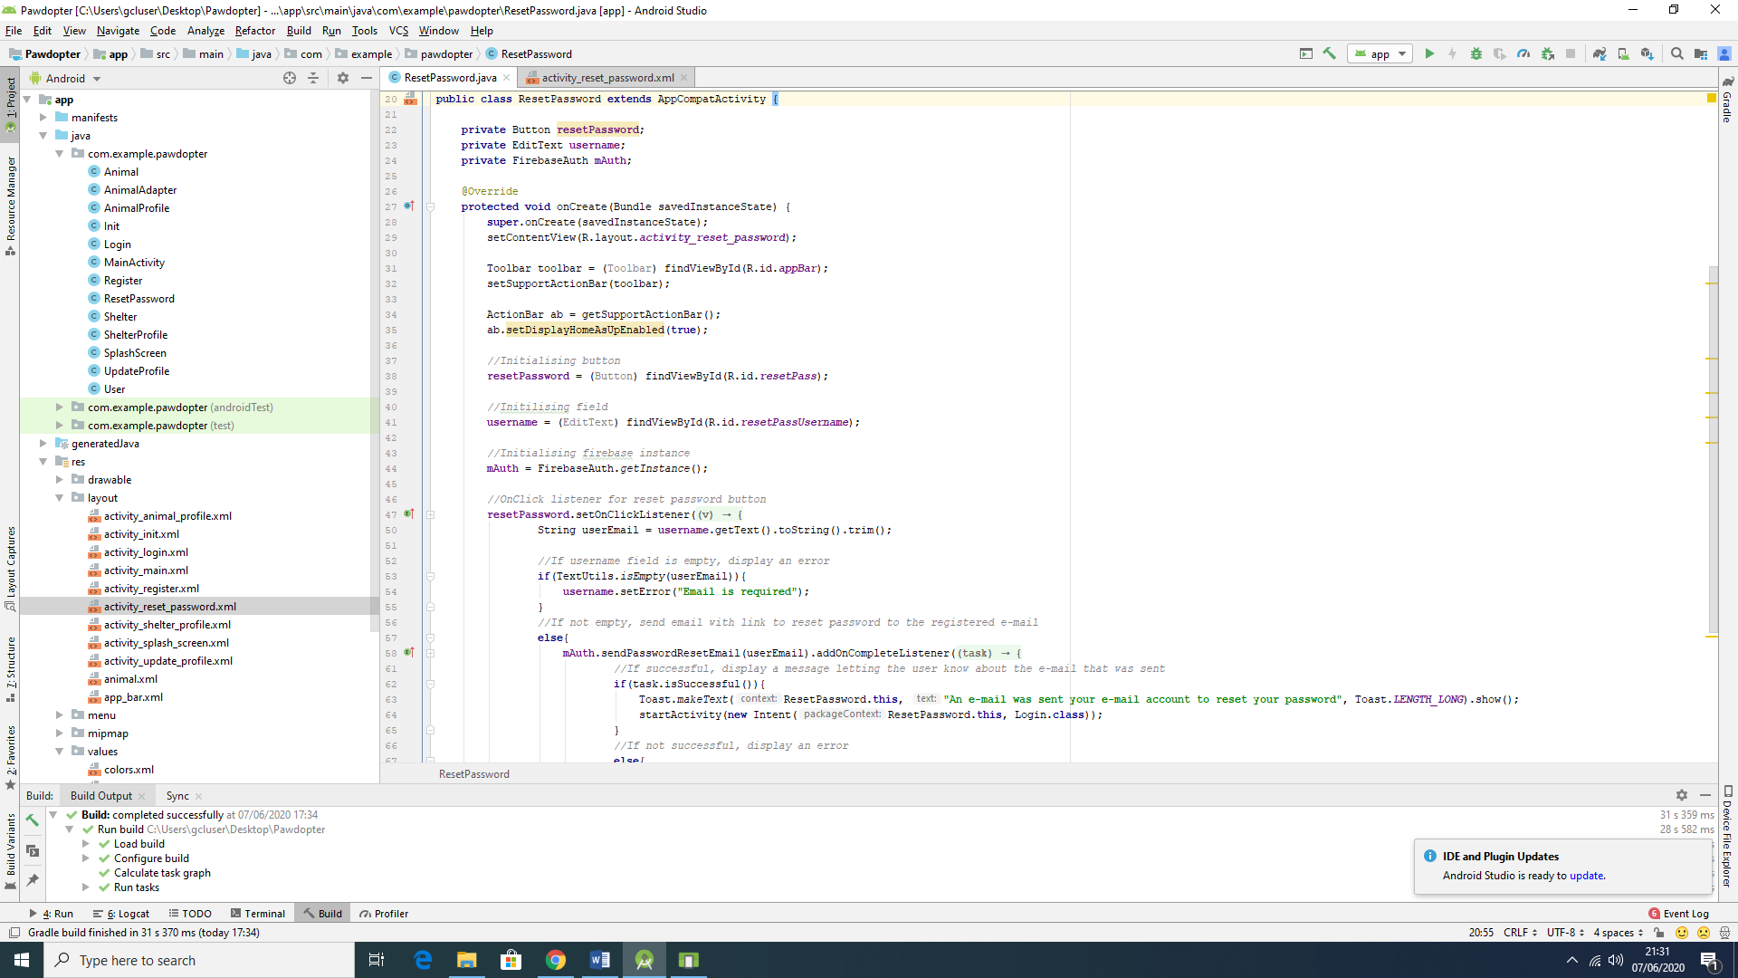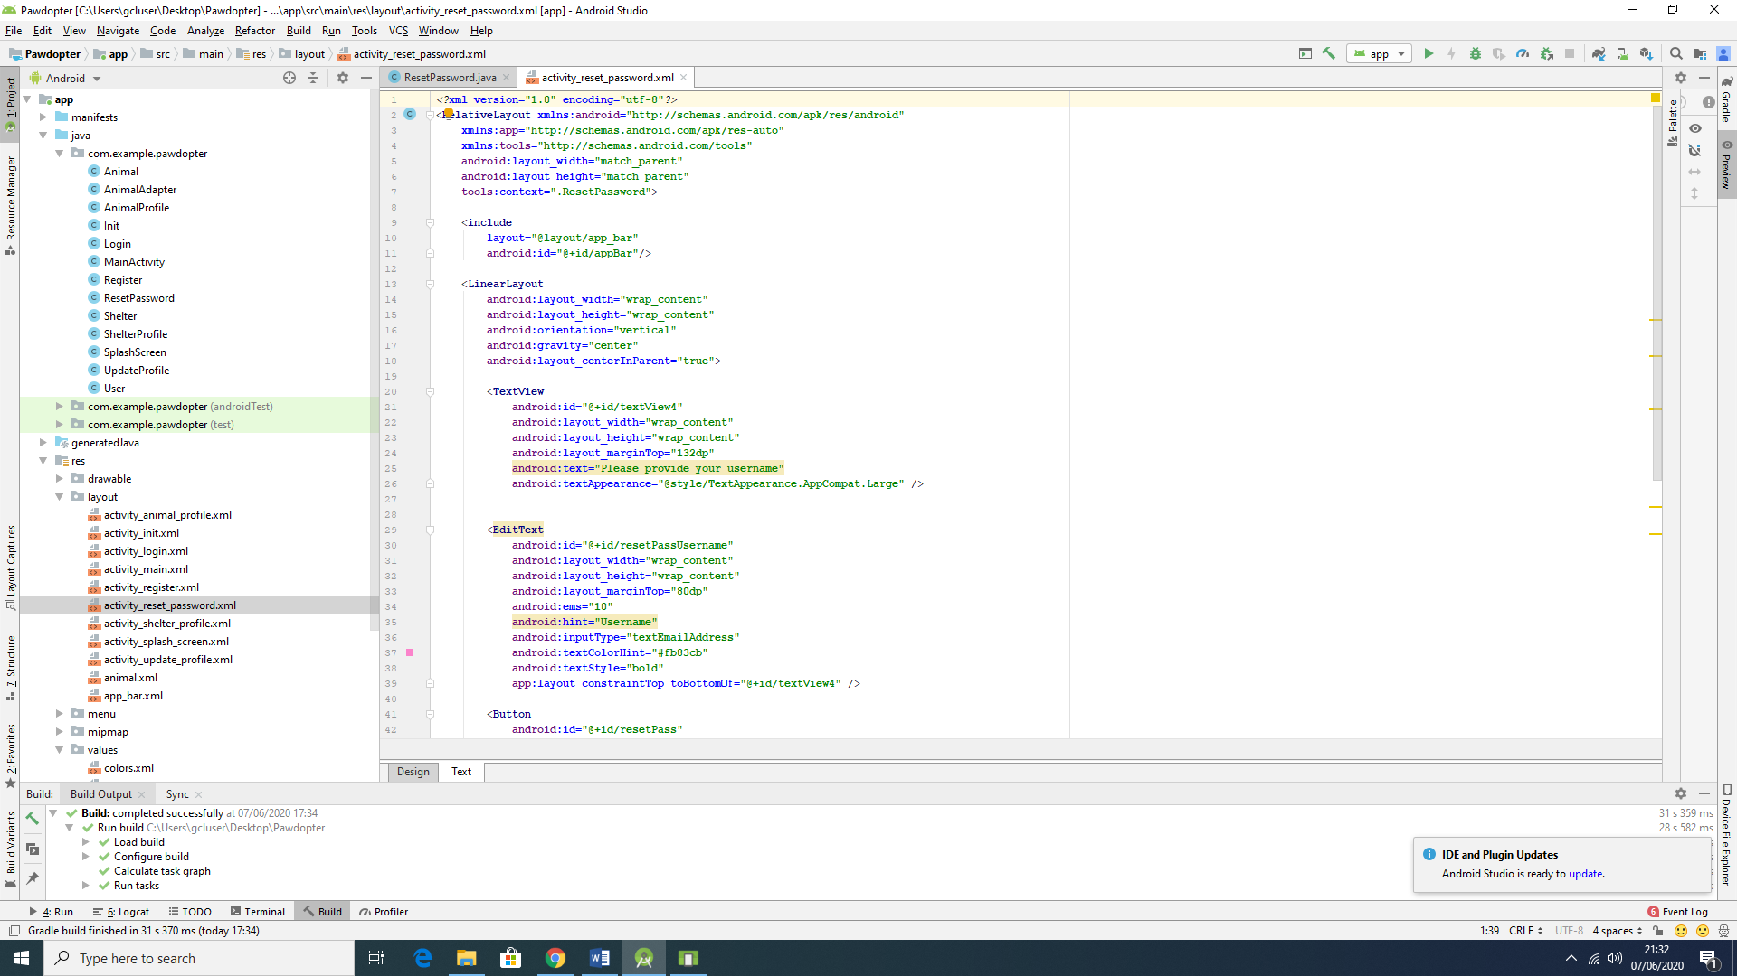

Figure 4.8b: Snippets of Code for Screen 8: Reset Password Screen

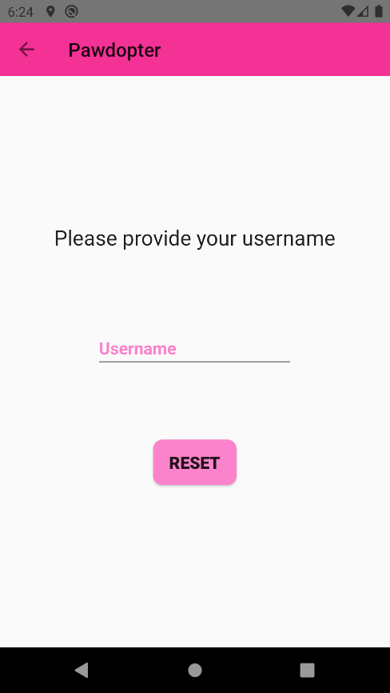

Figure 4.8c: Snapshot of the Actual Application Screen 8: Reset Password Screen

The wireframe and the actual screen differ on aspects mentioned before, such as logo and name of the application, which are replaced by a left arrow and followed by the name, respectively. Also, the name of the button was changed from *Send Request* to *Reset*, with the purpose of making it more user friendly. As mentioned before, the user will receive an automatically generated e-mail by the application, with a link to *reset* the password. Figure 4.8d shows the generated and sent e-mail.

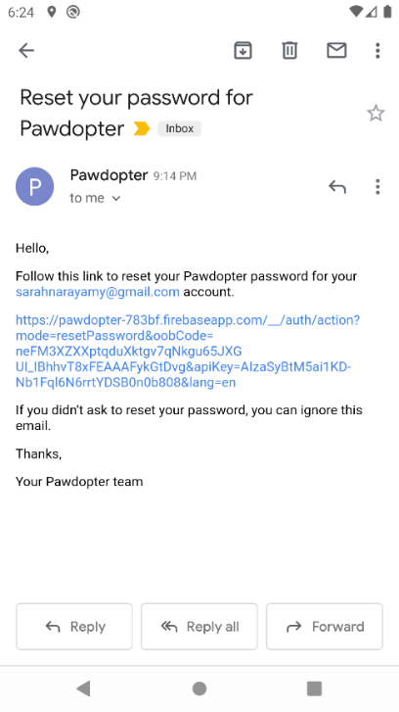

Figure 4.8d: Automatically generated and sent by the application e-mail to reset password

It is not possible to show the *before* and *after* images of the password being reset, because this functionality is made by the Firebase Authentication provider.

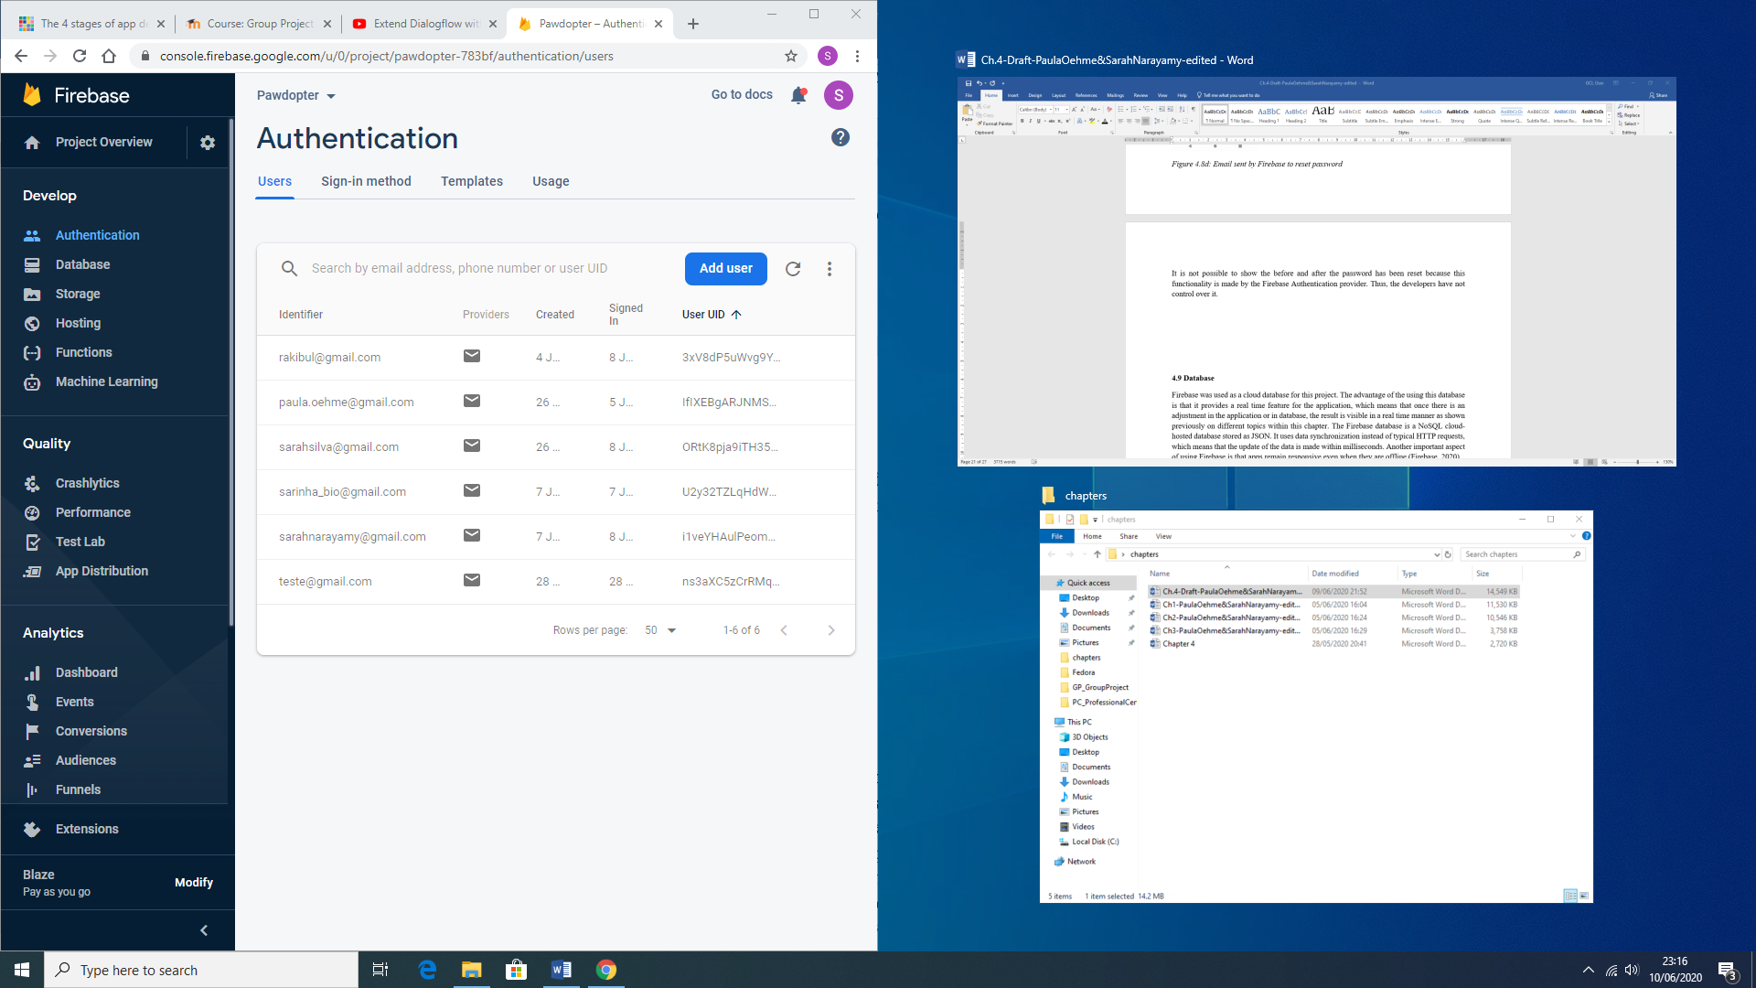

**4.9 Database**

*Google Firebase* was used as a *Cloud*-based *No SQL* database for this project. The advantage of using it is that it provides a *real time* updating features for the application, which means that once there is an adjustment in the application, or in database, the result is visible in a real time manner, as demonstrated previously in different sections of this chapter. The *Firebase* database is a *NoSQL* *cloud*-hosted database, stored as JSON. It uses data synchronization, instead of typical HTTP requests, which means that the update of the data is made within milliseconds. Another important aspect of using *Firebase* is that apps remain responsive, even when they are offline (Firebase, 2020).

Figure 4.9a shows the general representation of the application database with each collection (table), as an entity, as discussed in Chapter 3. It is important to mention that since a shelter’s interface was not created, due to time constraints, each animal and animal-related information was hard-coded into the database. All this information can be retrieved by the application in the code, using *Android Studio*, but the application does not make changes onto the database, except for the User collection (table).

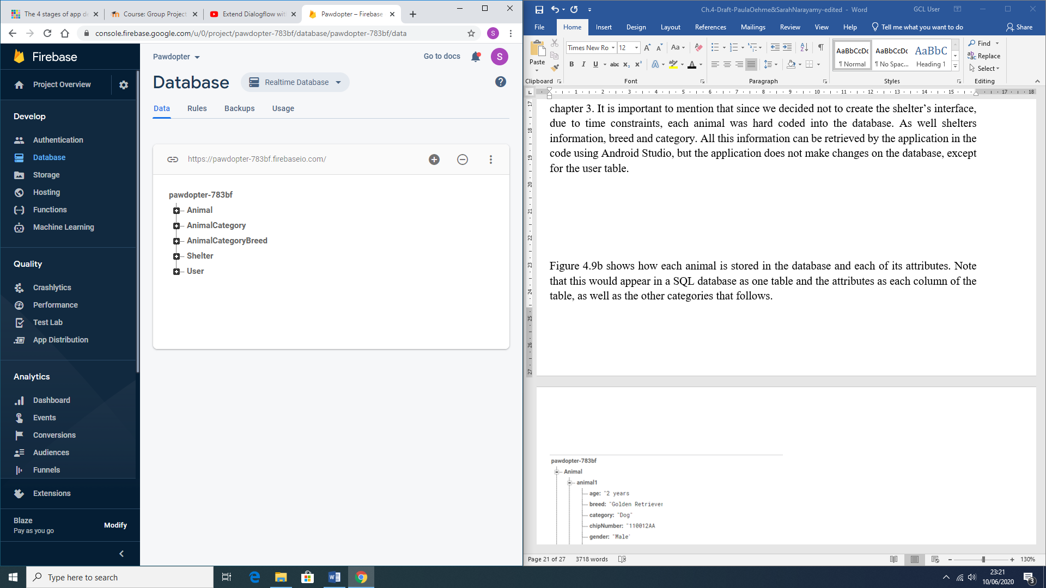

Figure 4.9a: Representation of the Application’s Database and its Collections (Tables)

Figure 4.9b shows how the Animal collection (table) and how each animal record is stored in it within the database, with each of its attributes. Note, that this would appear in a SQL database as a table, and the attributes as columns of the table (same is with the other collections that follows as description).

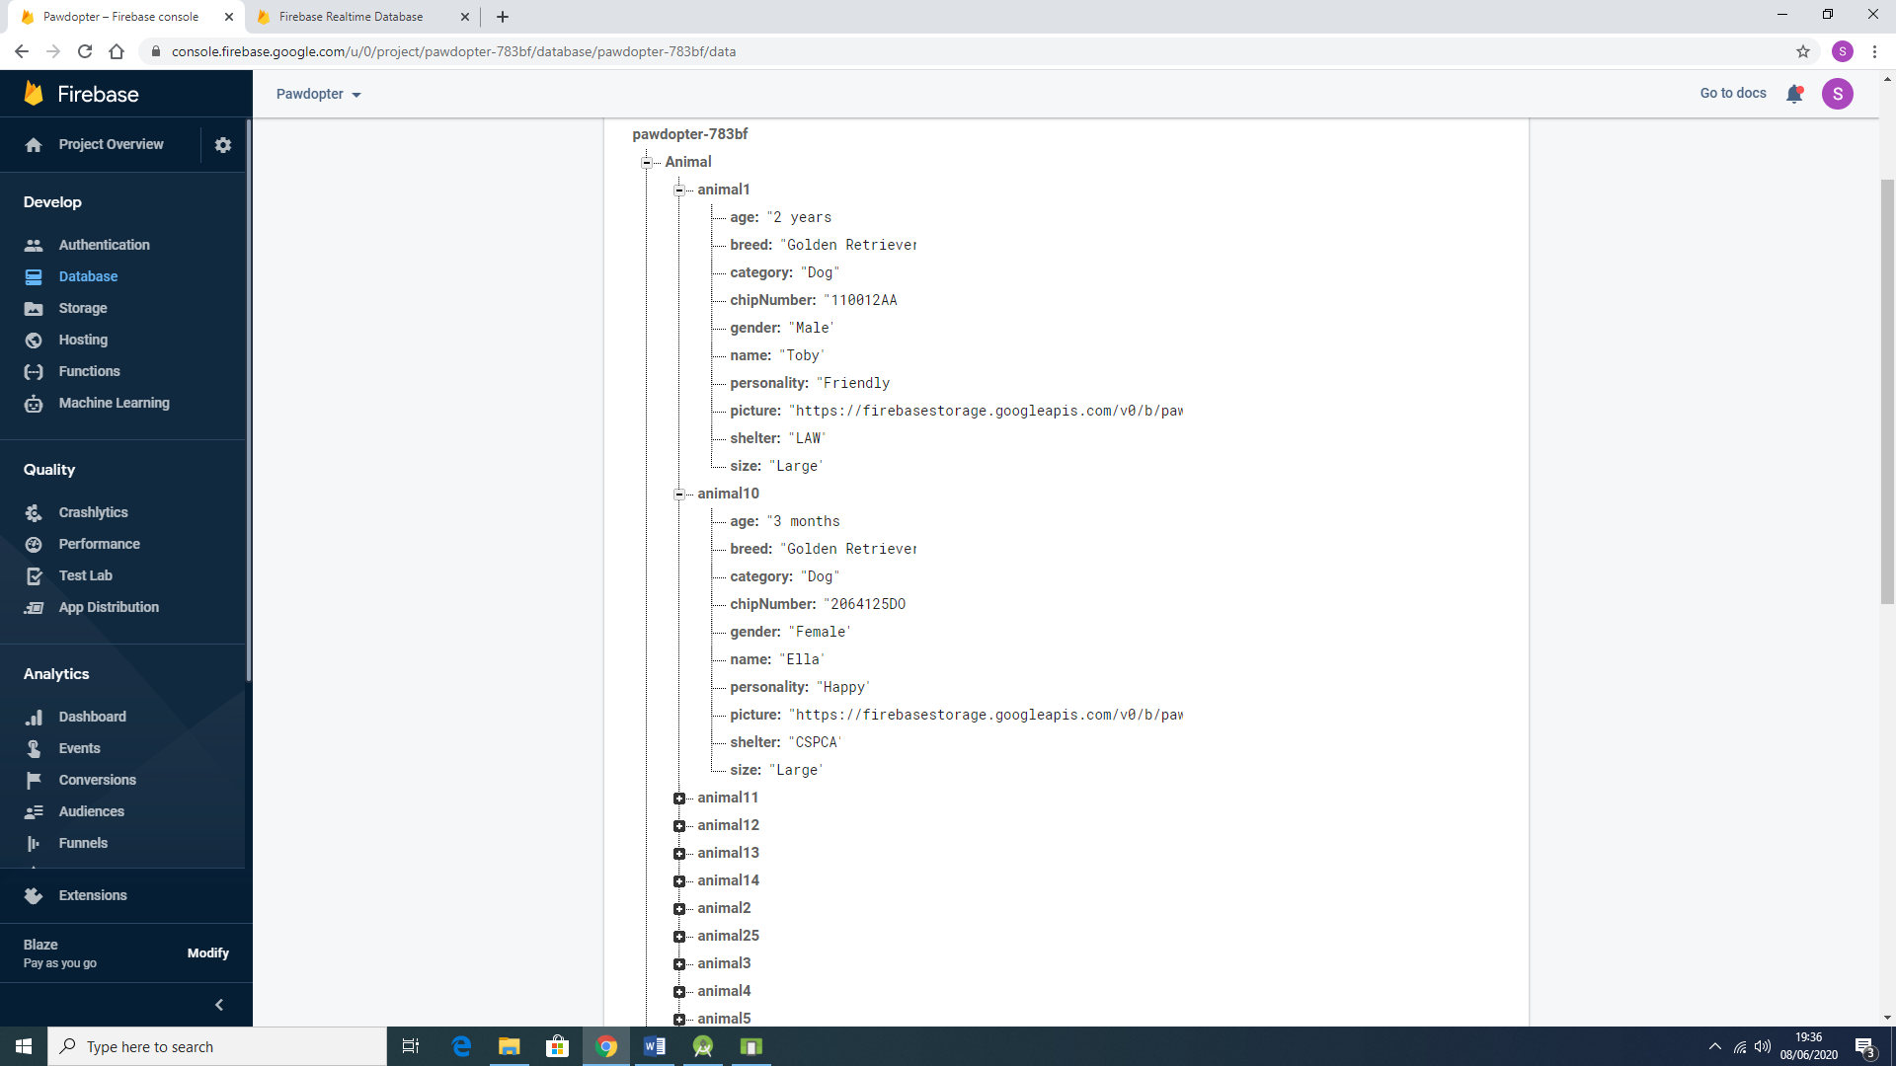

Figure 4.9b: Representation of the Animal Collection (Table) and its Attributes (and their Values), stored in the Database

Figure 4.9c shows how *Animal Category* collection is stored in the database. As mentioned before, this collection would be considered a Table, and the attribute is applied into the Animal collection as described and shown above.

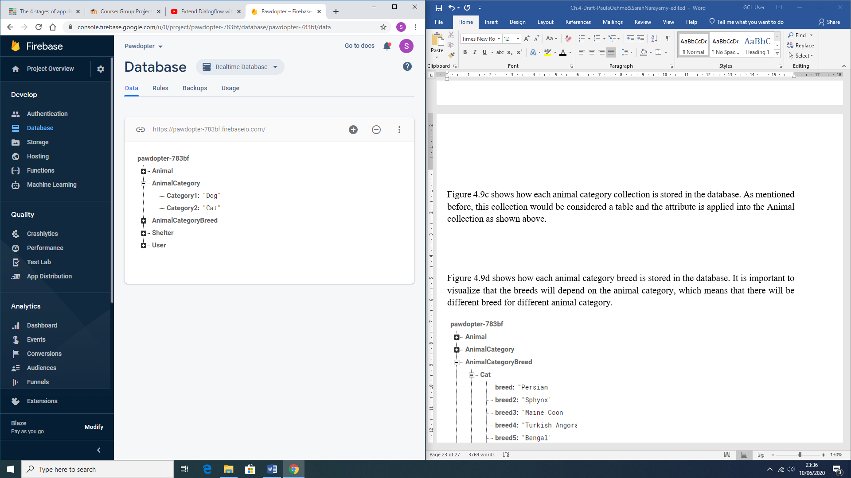

Figure 4.9c: Representation of the Animal Category Collection in the Application Database

Figure 4.9d shows how each Animal Category *Breed* is stored in the database. It is important to visualize that the *breeds* will depend on the *animal category*, which means that there will be different breeds for different animal categories.

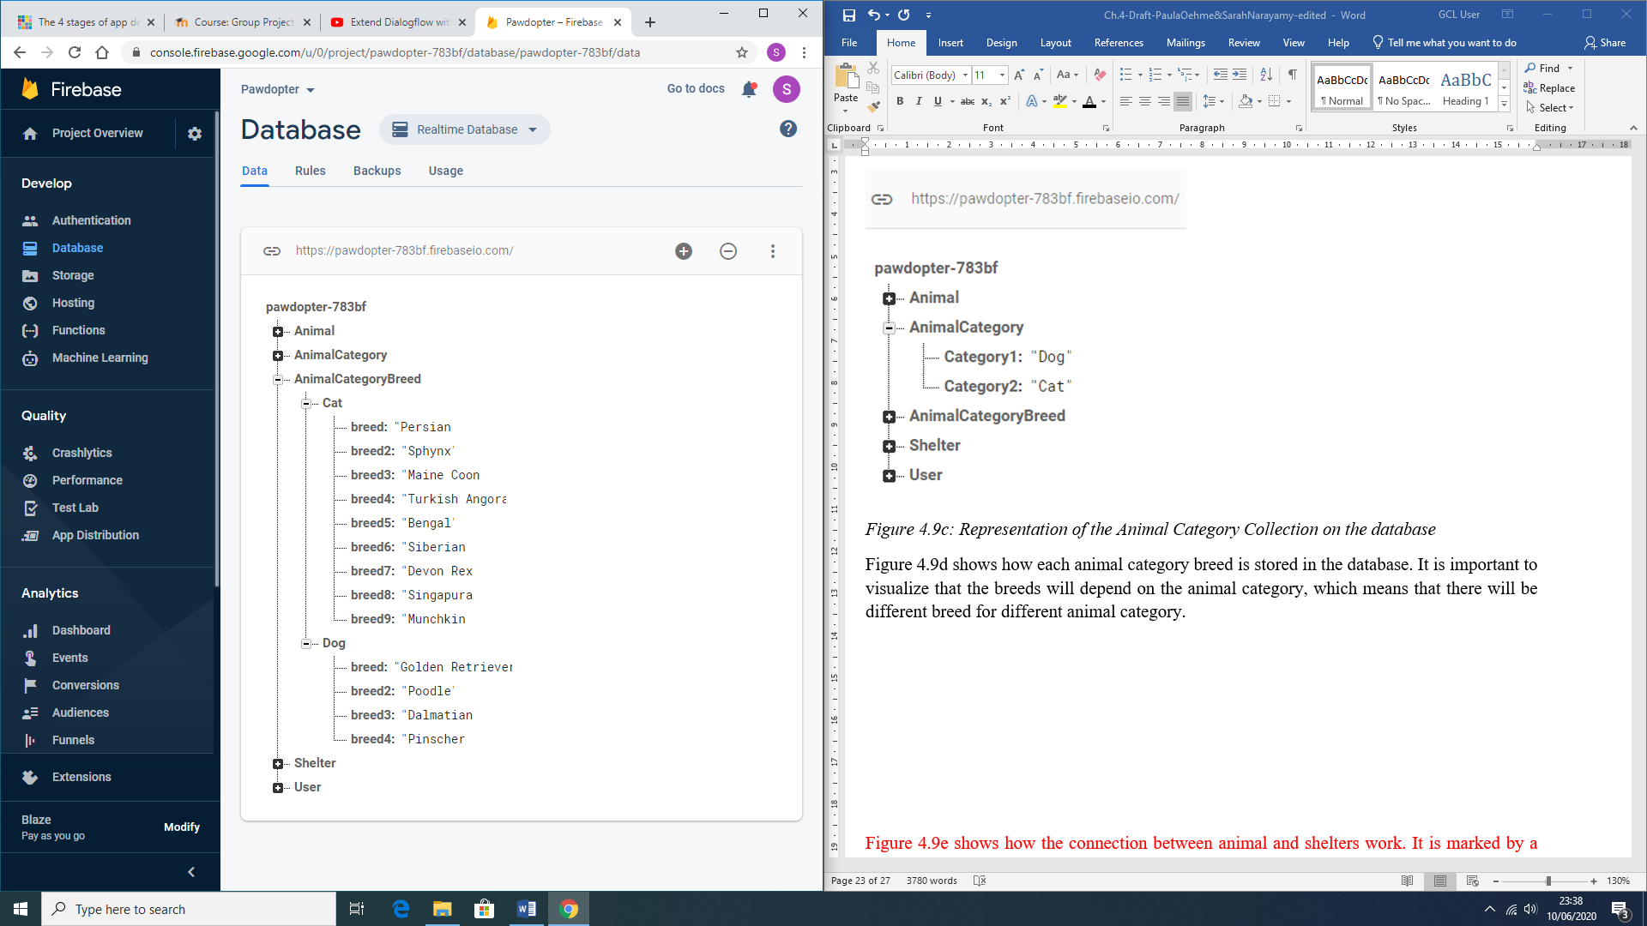

Figure 4.9d: Representation of the Animal Category Breed collection in the Application Database

Figure 4.9f shows how each shelter record is saved in the database. The *Shelter* collection (table) is also connected to the *Animal* collection (table), as shown on Figure 4.9b.

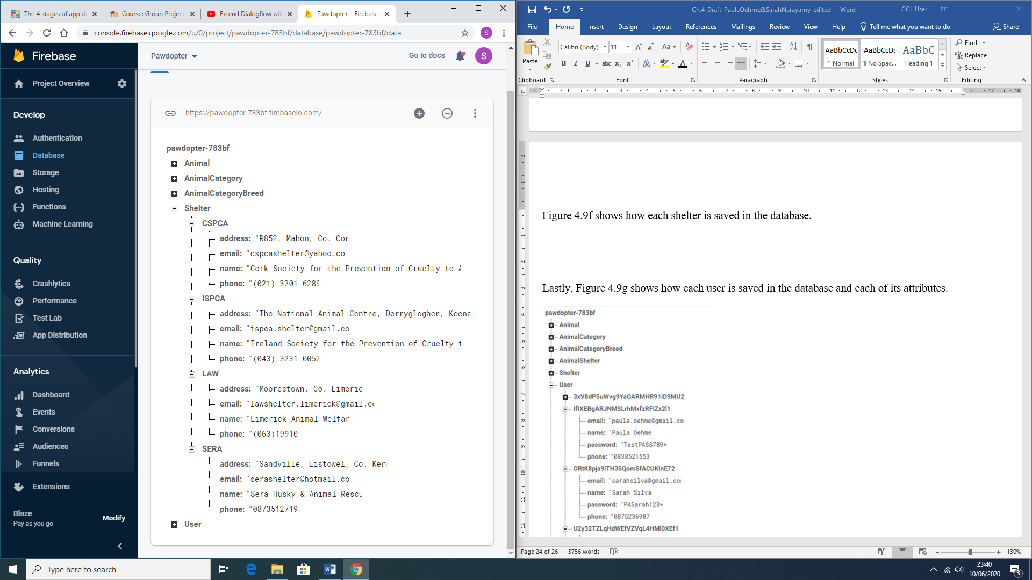

Figure 4.9f: Representation the Shelter collection in the Application Database

Lastly, Figure 4.9g shows how each User record is saved in the User collection of the application database with each of its attributes.

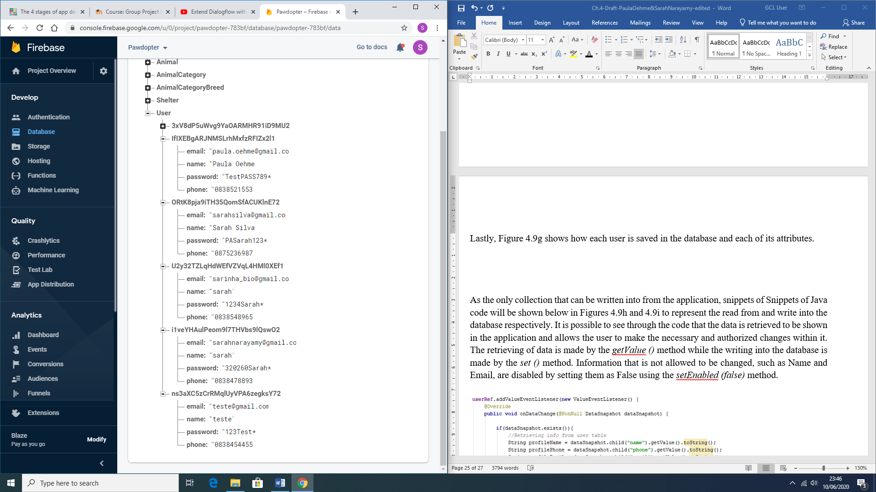

Figure 4.9g: Representation of the User collection in the database

As the only collection where records can be written into from the application, snippets of Java code are shown on Figures 4.9h and 4.9i to present the *read from* and *write into* the database processes, respectively. It is possible to see from the code, that the data is retrieved to be shown in the application and allows the user to make the necessary and authorized changes within it. The *retrieving* of data is made by the *getValue ()* method, while the *writing into* the database is made by the *set ()* method. Information that is not allowed to be changed, such as *Name* and *E-mail*, are disabled by setting them as False, using the *setEnabled (false)* method.

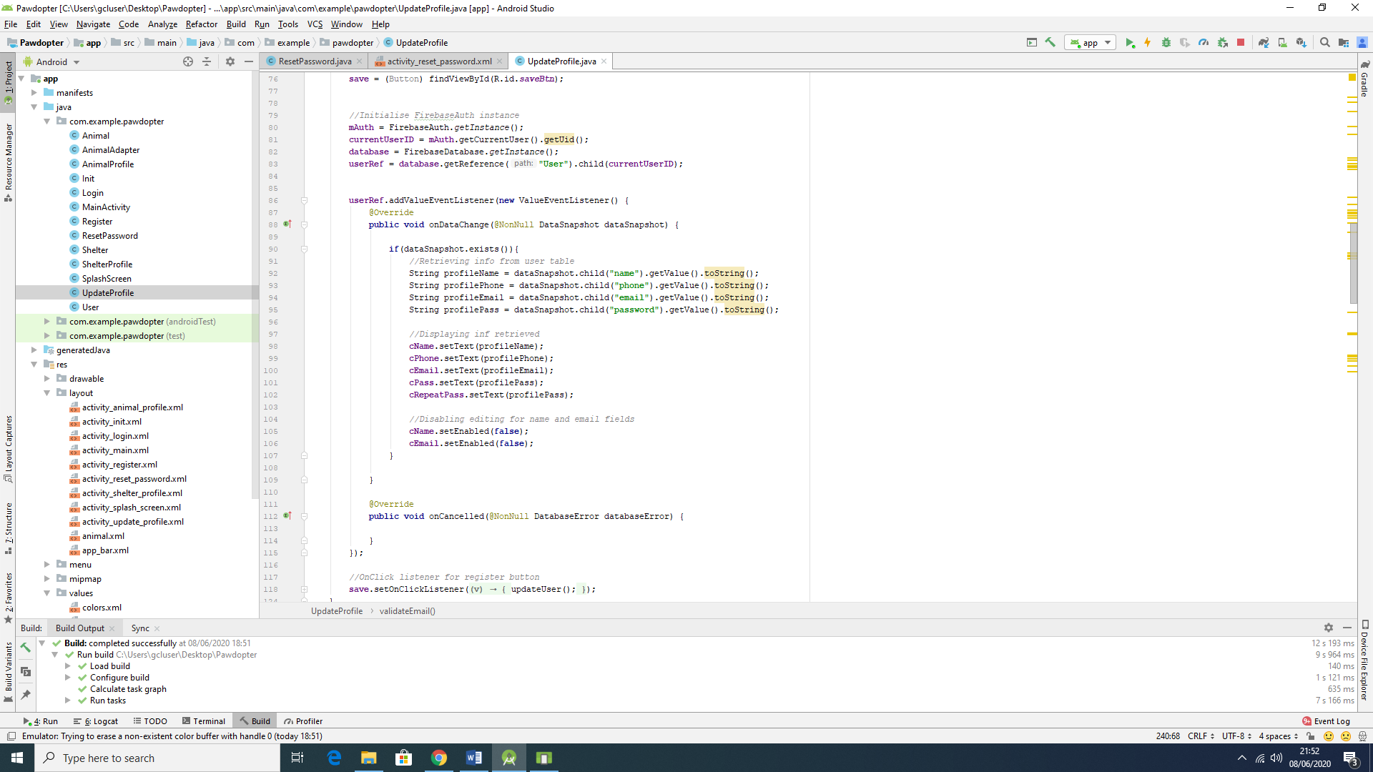

Figure 4.9h: Snippet of Code, showing read from and write into the User Collection of the Database

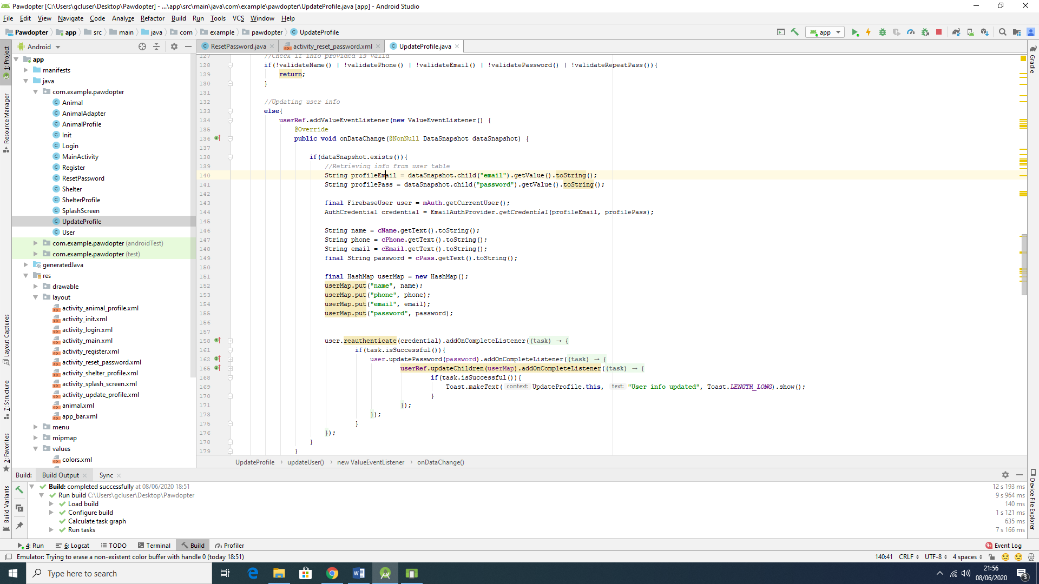

Figure 4.9i: Snippet of Code, showing read from and write into the User Collection of the Database

**4.10 DialogFlow**

*DialogFlow* is a platform that is powered by Google’s machine learning, which means that it incorporates this expertise, in order to develop products, such as Google Cloud Speech-to-Text (Dialogflow, 2020). This platform handles the interpreting and processing of natural language, so it can provide an end-user experience of high-quality conversation. It uses concepts, such as *Agents*, *Intents*, *Entities*, *Follow-up intents*, *Fulfilment for Integrations*, and so on. *Agents* are responsible for handling conversations with the end-user. By using *DialogFlow*, the end-user text or voice is translated into a structured data, that the application and services can understand. An *Intent* categorizes what is the user’s intention with the conversation. Several *intents* can be defined for one *agent*. An example of an *intent* is the *currency converter,* so if the user asks: “How much can I get in Brazilian Real?” then *DialogFlow* would match the expression to the *currency converter intent*. An *agent* is composed of training phrases, actions, parameters, and responses. Figure 4.10a show the connection between the user-*expressions*, the *agent*, and the *intents* (Google Cloud, 2020).

To active the *Google Assistant* within the *Google Home* IOT device, or through your smartphone, the user has to say an *activation phrase*, in this case “*Hey Google*”. The connection with the app is no different than that. In order for the *Google Assistant* to communicate with the application, the user must also say an *activation phrase*, in this case it is “*Talk to Pet Finder App”.* The reason why it uses this phrase, instead of “*Talk to Pawdopter*” (which is the actual name of the application), is because *Google Assistant* is not capable of recognizing the word *Pawdopter*. Also, Google has a rule about such activation phrase, which says that it has to have at least two words for *Google Assistant* to recognize it. Thus, in order to have the connection with the application, the activation phrase to be said to *Google Assistant* is: “Hey Google, Talk to *Pet Finder* App”.

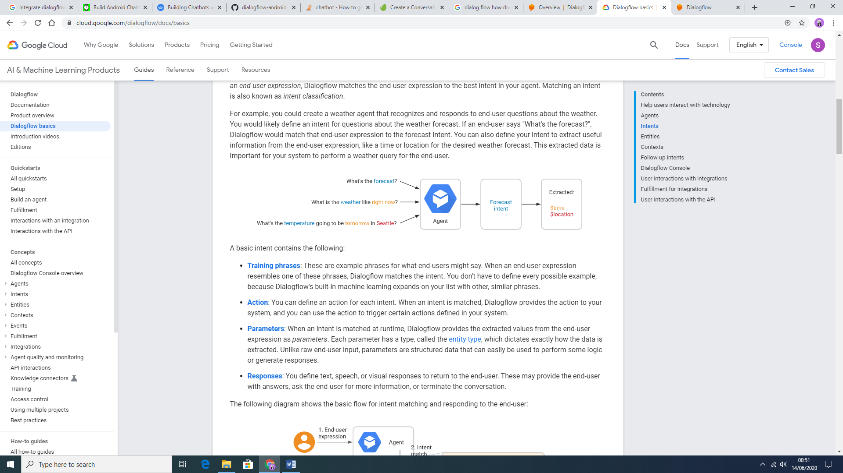

Figure 4.10a: DialogFlow Agent and Intent demo (Google Cloud, 2020)

Still, according to Google Cloud (2020), “each intent parameter has a *type*, called the *entity type*, which dictates exactly how *data* from an end-user *expression* is extracted”. Follow-up intents are used to set the context for pair of intents automatically, usually these follow-up intents are common user’s replies, such as “Yes”, “No”, or “Cancel”, but they can also be created according to the developers’ needs. Fulfilments are used in *DialogFlow* to provide a more dynamic response to the user. That means that when the fulfilment is enabled for an intent, the response that *DialogFlow* provides is based on calling a service defined by the developer, such as a database. Figure 4.10b shows the flow of the fulfilment process.

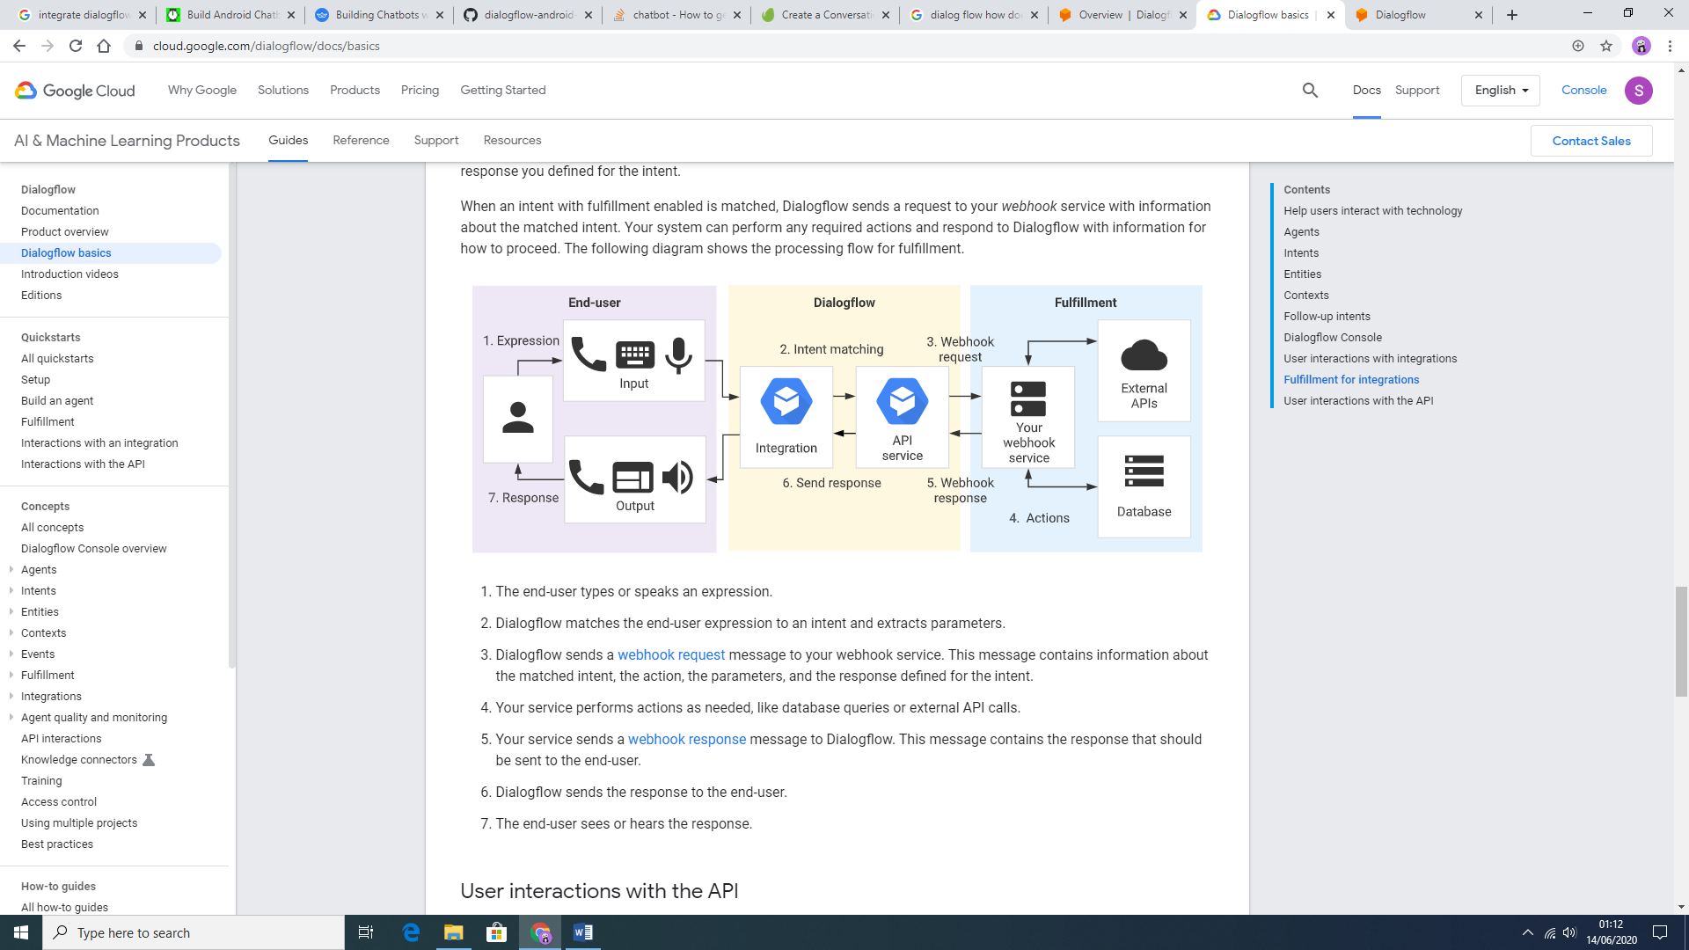

Figure 4.10b: Fulfilment Processing Flow (Google Cloud, 2020)

This process is developed with *JavaScript* as a language. Figure 4.10c: represents snippet of code for the fulfilment in this project, showing a function that creates a list of *breeds* from the database, according to what the user has asked for.

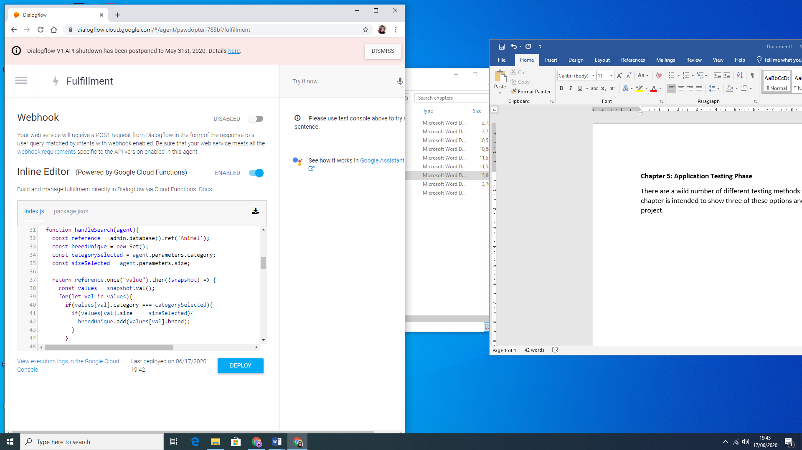

Figure 4.10c: Snippet of Code from the Fulfilment in DialogFlow

Figure 4.10d shows the structure of the Intent for the current application, called *LookingForPet*.

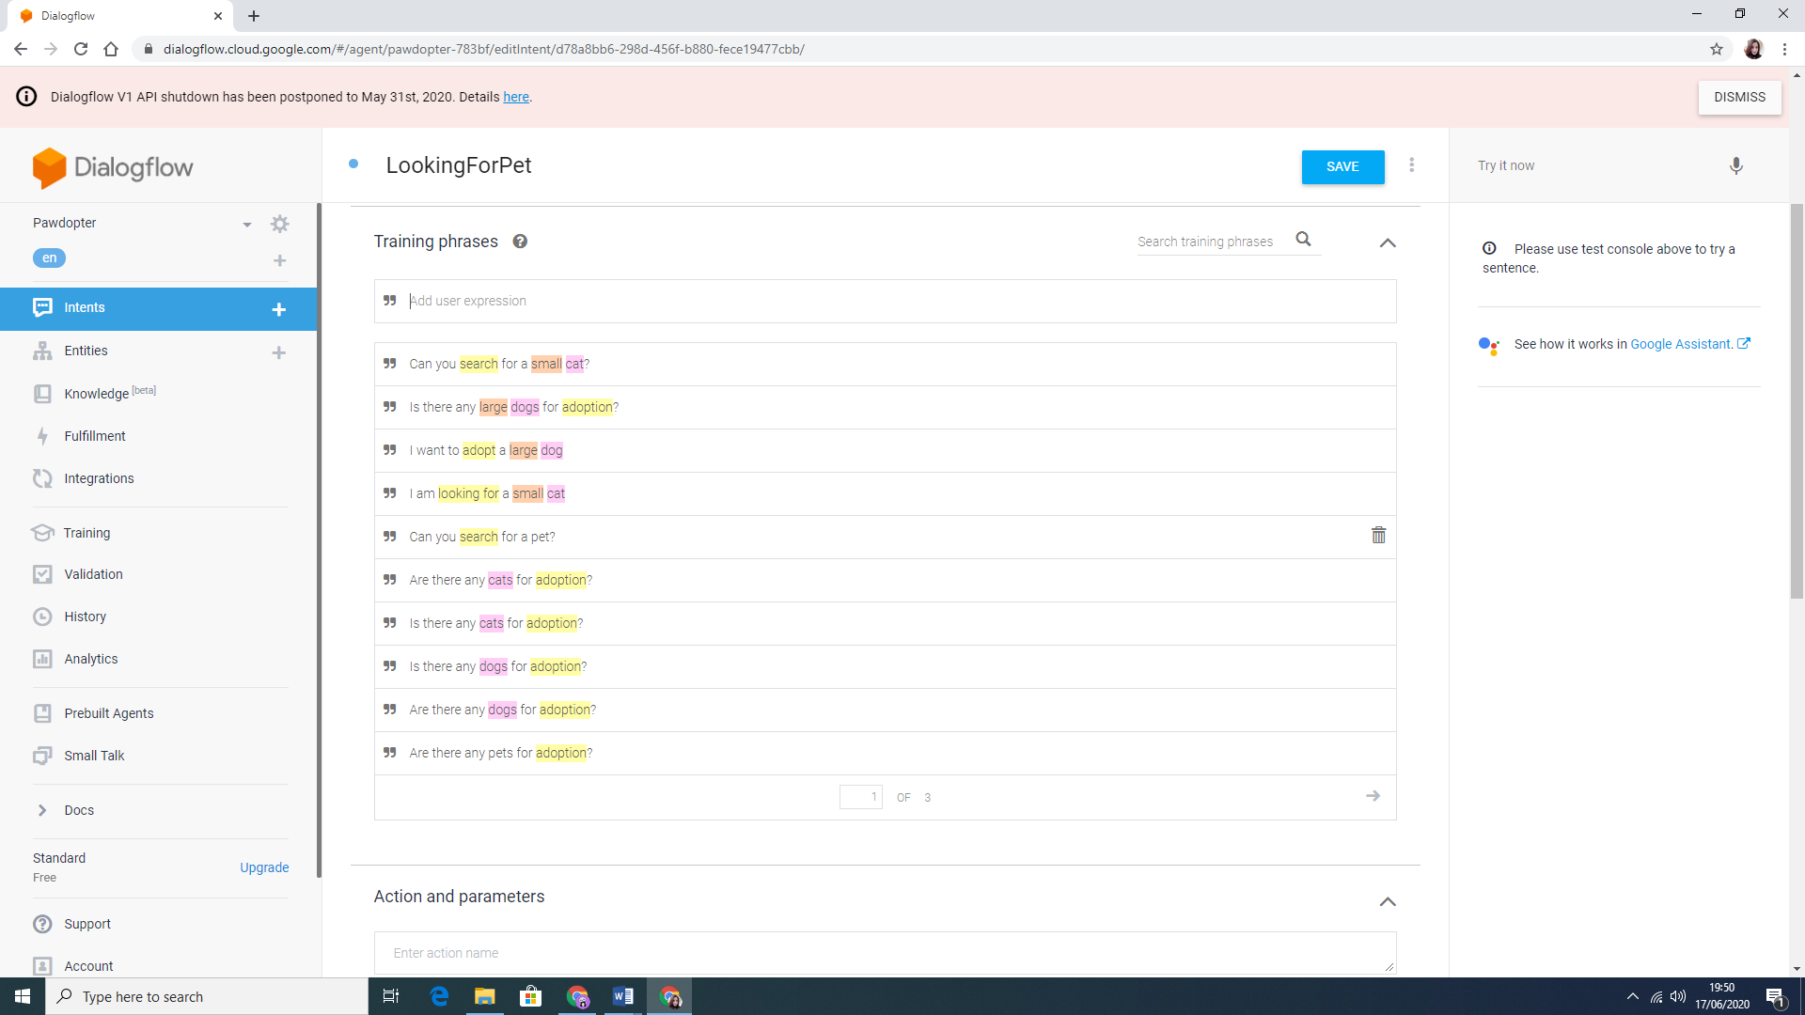 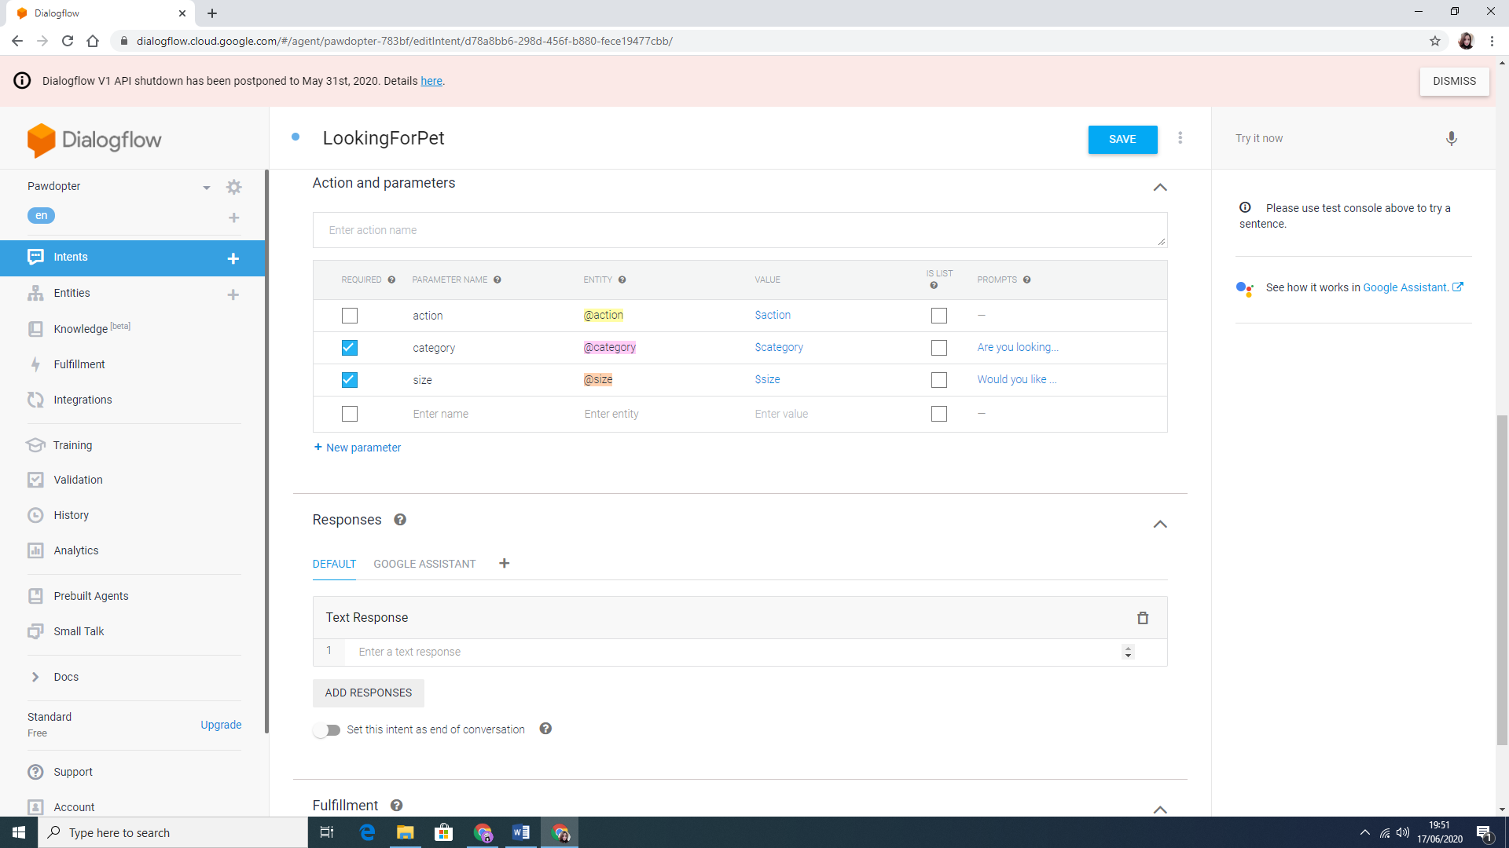

Figure 4.10d: LookingForPet Intent Structure

Figure 4.10e show a Follow-up intent structure, according to the chosen Breed, after selecting the category and size of the desired pet.

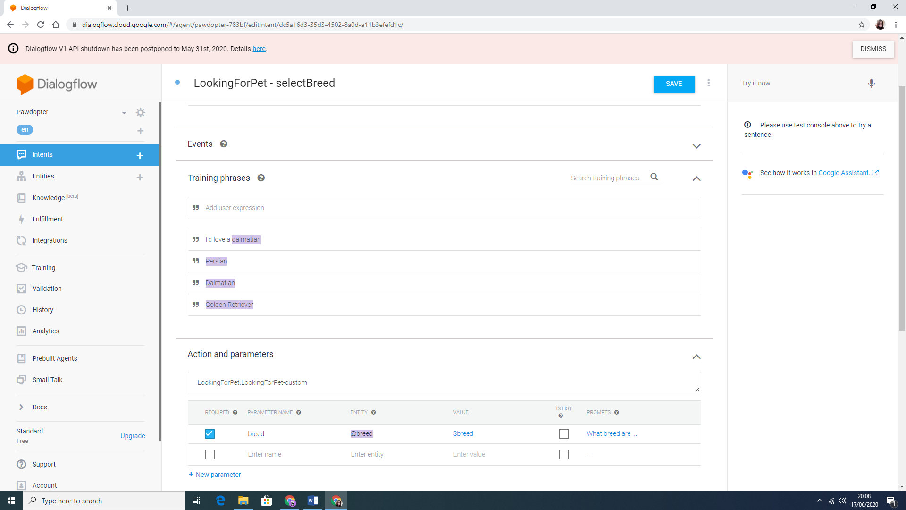

Figure 4.10e: Follow-up Intent Structure

Figure 4.10f shows the Entities created for the current application on the left, and the structure of one of these Entities on the right. Each entity, such as cat or dog, has its synonyms and the Fuzzy matching selection allows Google Assistant to match user’s input with the entities, even when the spelling or pronunciation are not correct.

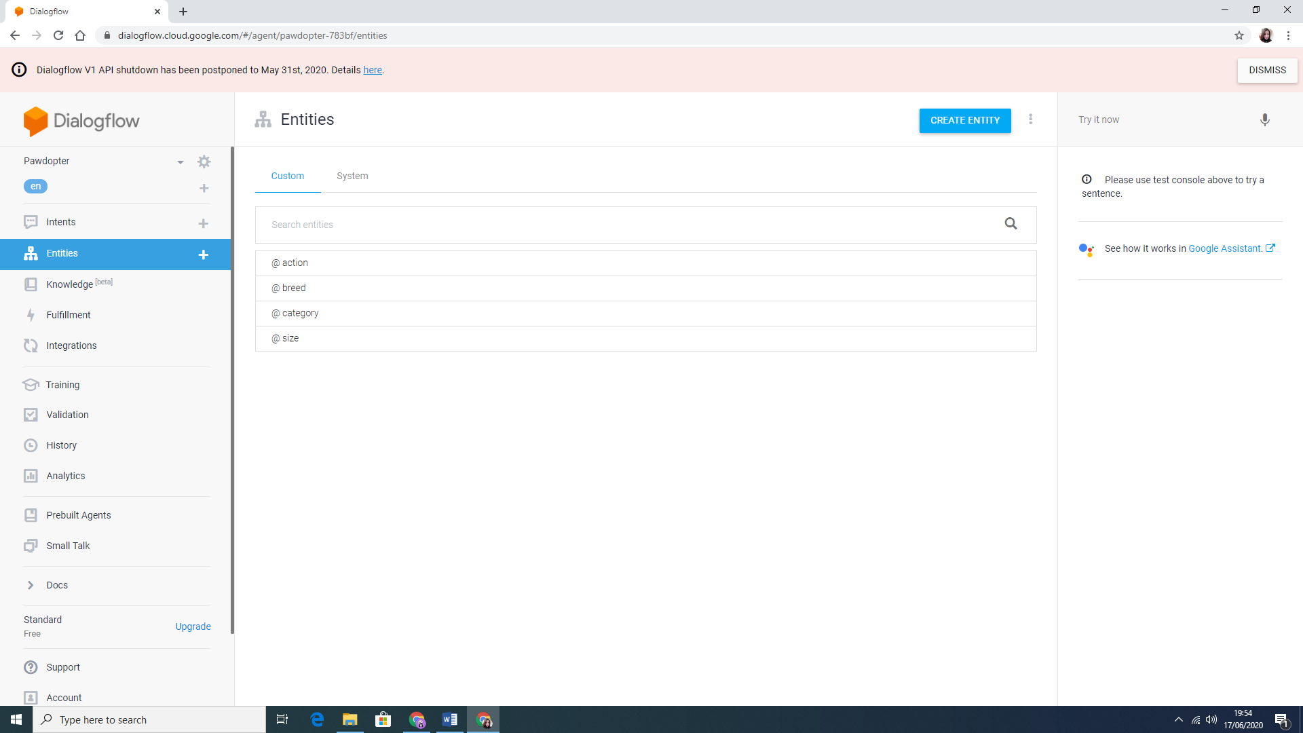 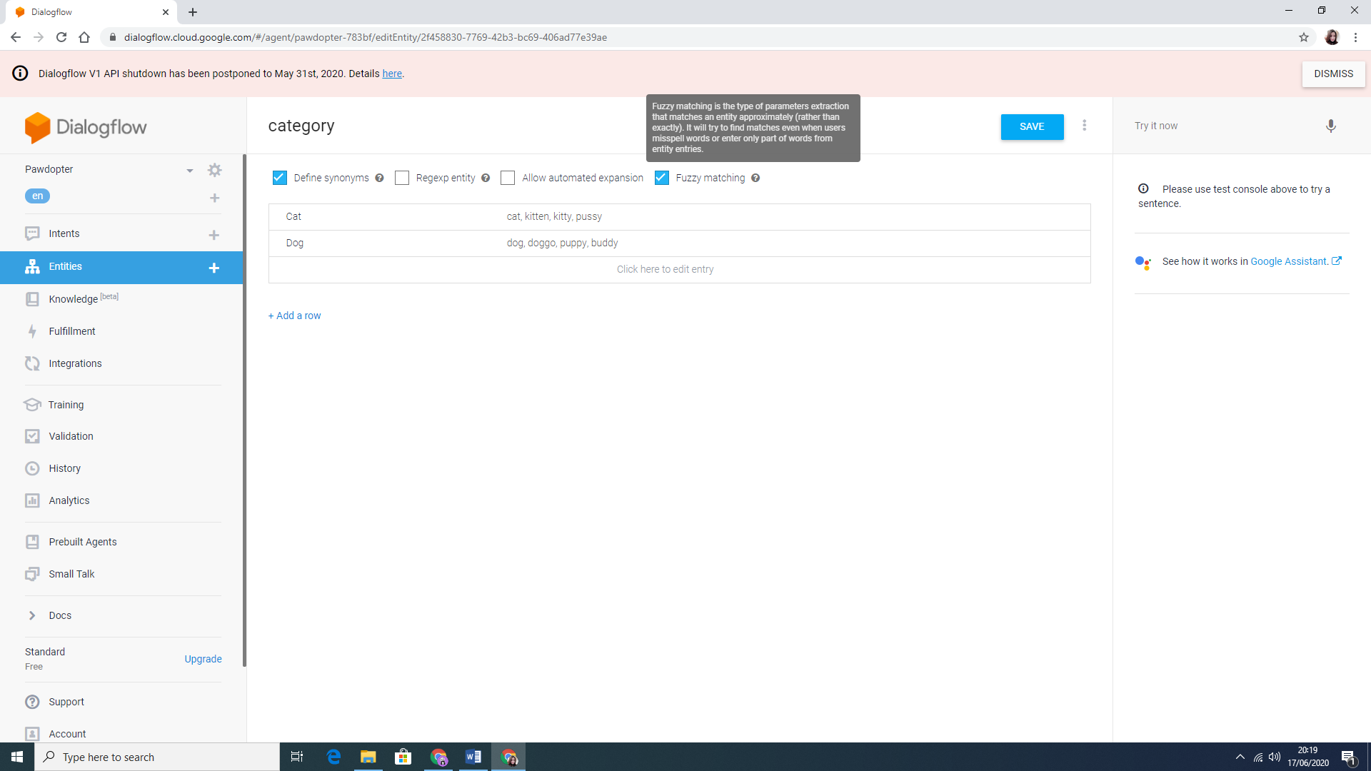

Figure 4.10f: Entities and Entity Structure

**4.11 Three-Tier Architecture**

This project is based on a Three-Tier Architecture for software development that consists of *Presentation* (*User) Tier, Application Tier, and Database Tier*. *The Presentation Tier, or User Tier*, allows the communication with the other two tiers. It represents the Graphical User Interface (GUI), and the communication with the other tiers is made through Application Program Interface (API) calls. In this project, *JavaScript* was used to create the *Presentation Tier*. The *Application Tier,* or *Logic Tier,* uses a programming language (Java) to provide the business logic and the processing of user input for obtaining data and making decision(s), to support the application’s functions. These functions include network management, security, datastore access, etc. In the current project, *Android Studio* with *Java*, as a language, were used. The last tier of this architecture is the *Data Tier,* or *Database Tier,* which is responsible for storing the information. Google’s *Firebase* was used for this project (Rouse, 2020). Figure 4.11a shows the Three-Tier architecture.

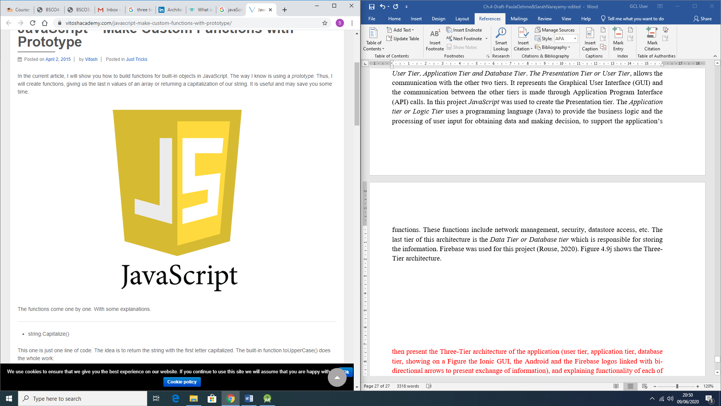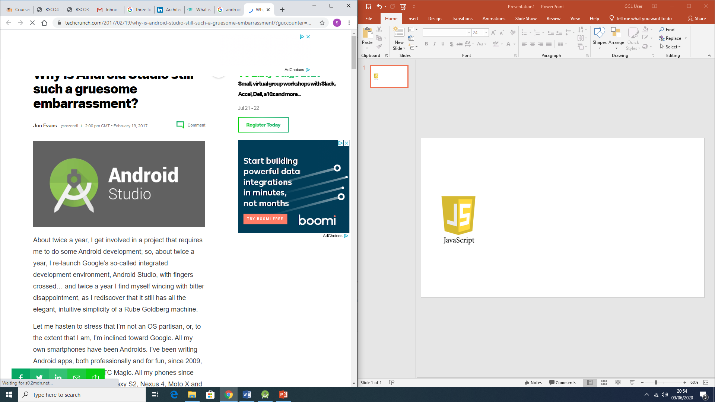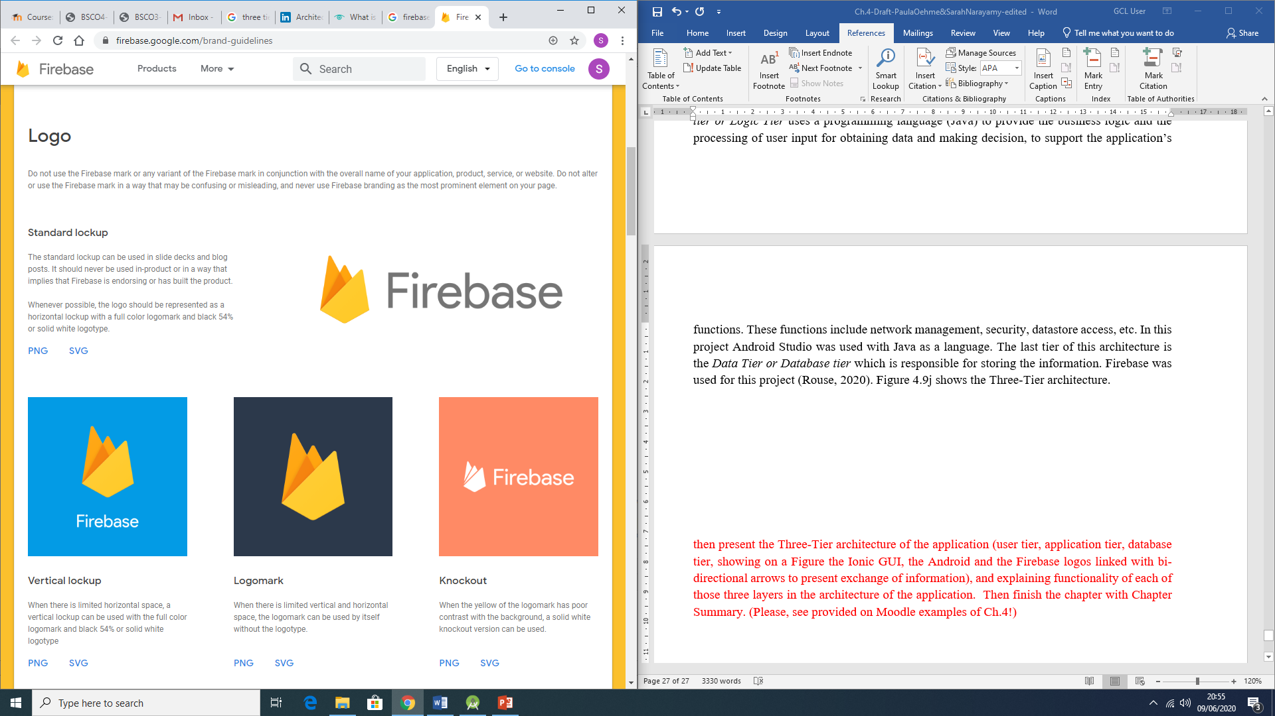

Figure 4.11a: Representation of the Three-Tier Architecture

**4.11 Chapter Summary**

This chapter was important to detail the Design and Coding processes of the current Project’s mobile application. Each section illustrates the importance of planning the design, and the necessary changes being made during the coding process, due to different reasons as explained. These changes were mostly done, in order to enhance either the appearance, or the functionality of the application, or both.

The next chapter will discuss the *Testing* Phase of the application development process.

**References**

Dialogflow, 2020. *Dialogflow.* [Online]   
Available at: https://dialogflow.com/  
[Accessed 13 June 2020].

Firebase, 2020. *Firebase.* [Online]   
Available at: https://firebase.google.com/docs/database

Google Cloud, 2020. *Google Cloud.* [Online]   
Available at: https://cloud.google.com/dialogflow/docs/basics  
[Accessed 13 June 2020].

Rouse, M., 2020. *Techtarget.* [Online]   
Available at: https://searchsoftwarequality.techtarget.com/definition/3-tier-application  
[Accessed 15 June 2020].

Techopedia, 2016. *Techopedia.* [Online]   
Available at: https://www.techopedia.com/definition/9505/splash-screen  
[Accessed 19 June 2020].